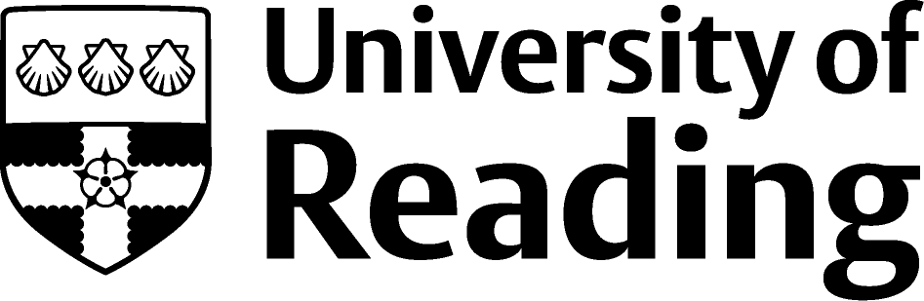
School of Health and Social Care

The BSA Ageing, Body and Society study group presents a
one day conference
Palmer Building, University of Reading:
Wednesday 25th June 2008

Relaunch: Ageing, Body and Society Study Group

Programme

10. 00 – 10.30 Registration and Tea / Coffee

10.30 – 11. 30 Welcome and Key Note Address:
Gerontology Embodied: Age and Biological Culture
Professor Stephen Katz (Trent University, Canada)

11. 30 – 12. 30 Paper Session 1: (3 parallel sessions)

Session A: Digital / computer technologies

Look at My Digital Body? The Older Woman in SagaZONE
Joanne Garde-Hansen (University of Gloucestershire)

E-scaping the ageing body? Computer technologies and constructions of ageing
Christina Buse (University of York)

Session B: Health / Care

Inter-personal Aspects of Receiving Care for Activities of Daily Living: Intimacy and Nudity
Brenda Roe (Edge Hill University)

An exploration of the embodied nature of older people’s perceptions of, and responses to, falls and the consequences for fall prevention interventions
Angela Dickinson (University of Hertfordshire)

Session C: Medical sociology

“The Fittest Corpse on the Block”: Exploring Death Anxiety and the Midlife Body
Bethany Morgan (University of Essex)

The ageing body in medical sociology
Paul Higgs (University College London) and
Ian Rees Jones

12. 30 – 13.30 Lunch

You are invited to bring your lunch and join us for the Ageing, Body and Society annual meeting between 12.45 and 13.15

13.30 – 14.30 Paper session 2: (3 parallel sessions)

Session A: Embodied identities

Resistant, leaky or ‘working alright’? - some empirical and theoretical reflections on older men’s embodied subjectivities
Linn Sandberg (Linköping University)

Embodied identity processes: Bodily paradox and twofold bodily meanings
Clary Krekula (University of Karlstad)

Session B: Health / Ageing

Moral discourses, health and old age: some continuities and disjunctures from the history of stroke
Katharine Daneski (Swansea University)
Paul Higgs and Myfanwy Morgan

At Home in the City: Ageing Bodies, Health and the Built Environment
Carolyn Mahoney (University of Sussex)

Session C: Health / Identities

Older People Don’t Take Drugs!
Caryl M Beynon (Liverpool John Moores University)
Lucy Pickering, Brenda Roe, Jim McVeigh and Paul Duffy

Early signs of aging: Attitudes towards faces and bodies post-pregnancy
Andrea Tonner (University of Strathclyde)

Talking about old age and body
Outi Jolanki (University of Tampere)

14.30 – 14.45 Tea

14.45 – 15.45 Paper Session 3: (3 streams)

Session A: Theoretical / empirical

Ageing without agency: Theorizing the fourth age
Chris Gilleard (University College London) and
Paul Higgs

Body Episodes and the Labour Process Throughout the Lifecourse
Kathleen Riach (University of Essex)

Session B: Exercise / ageing

Mid-Life Women in the Gym: Stories of Physical Culture and Ageing.
Cassandra Phoenix (University of Exeter) and
Jenny Laycock

Exercise and the Reconstruction of the Ageing Body
Emmanuelle Tulle (Glasgow Caledonian University)

Session C: Identity / image

Dance and Cultural Identity for the Ageing Body
Sue Paulson (City University) and
Carla Willig

In the Hairdresser’s Chair: Negotiating an appropriate image in later life
Caroline Holland (The Open University) and
Richard Ward

15.45 – 16.30 Plenary address:
Clothing, Identity and the Embodiment of Age
Professor Julia Twigg (University of Kent, UK)

16.30- 16.35 Closing remarks



