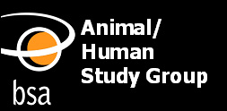

Making Connections:
Facilitating networks in the field of human-animal studies

First Meeting of Postgraduate Members (2010)

Date: Thursday 13th of May 2010

Time: 11.30 am – 5.00 pm

Venue: BSA Meeting Room, Suite 2,
2 Station Court, Imperial Wharf, Townmead Road,
Fulham, SW6 2PY

For further information about the meeting please contact:

Dr Rhoda Wilkie: r.m.wilkie@abdn.ac.uk
Dr Rebekah Fox: r.fox@kingston.ac.uk
BSA website: http://www.britsoc.co.uk/specialisms/AHSG.htm
http://www.britsoc.co.uk/events/meetingroom

The BSA is a Company Limited by Guarantee. Registered in England and Wales. Company Number: 3890729.
Registered Charity Number 1080235.

