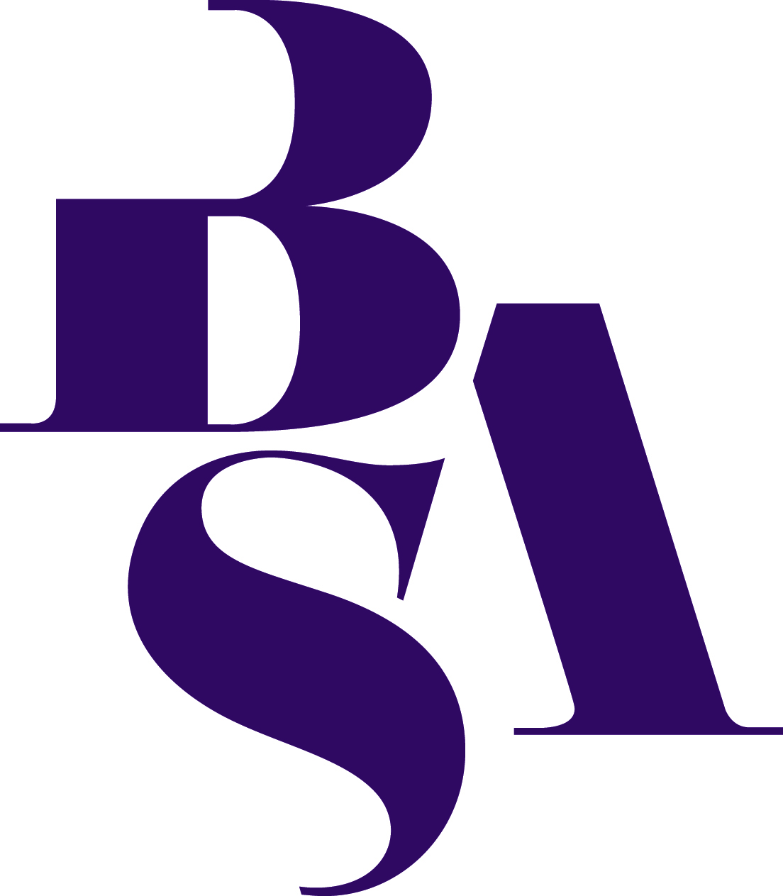
GIFT AID DECLARATION
I want The British Sociological Association to treat all donations which I make from the date of this declaration, until I notify you otherwise, to be treated as gift aid donations.
I confirm that I pay an amount of UK Income tax and/or Capital Gains tax to cover the amount that charities will reclaim on my donations in the tax year. I understand that other taxes such as VAT and Council Tax do not qualify. I understand that the charity will reclaim tax on every £1.00 that I give.
NAME
(Title)......................
Given names............................................................................................
Surname...................................................................................................
ADDRESS
............................................................................................………............. .................................................................................................................
POST CODE .....................................

SIGNATURE............................. ............. DATE.....................................

Please return to Kerry.collins@britsoc.org.uk (Company Secretary BSA)

