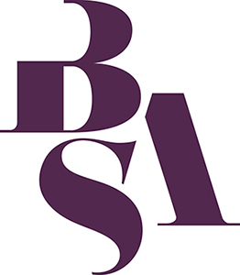
FOOD STUDY GROUP
JOINING FORM

The BSA Food Study Group is a forum for academics, practitioners and others involved or interested in sociological research on any aspect of food production or food consumption. It is a study group of the British Sociological Association and incorporates the Scottish Colloquium on Food and Feeding (SCOFF).
Members meet several times each year for a mixture of seminars, networking, longer themed sessions and lunch. Those with institutional support are asked to pay a one-off joining fee of £46. Membership is free for BSA members. Members are automatically registered with the e-mail discussion group via JISCmail. Students welcome (free registration).
To join the Food Study Group:
Please complete this form and email it to Julie Parsons at J.M.Parsons@plymouth.ac.uk.
And if payment is necessary:
BACS: Bank: Nat West. Sort Code: 52 30 44. Account no.: 23679832. Account name: The British Sociological Association. Please quote ref: ‘FoodSG’. For international transfer details contact Hannah.
Cheque: Make payable to ‘BSA food study group’. Send to British Sociological Association, Chancery Court, Belmont Business Park, Belmont, Durham DH1 1TW with a copy of the form.
Invoice: Provide details for invoicing on the form you send to Julie, who will forward it to the BSA for processing.

Name……………………………………………………………… Email…………………..………………….………………………….
Address…………………………………………………………………………………………………….……………..………………………………………………………………..……………………………… Postcode……………………..………………………………………
Telephone……………………………………………….…….….
Research interests…………………………………………………………………………………………………………………………….
Where/how did you hear about the group? ………….…………………………………………………………………………
BSA member? Yes (number……………………….. ) / No Student? Yes / No
Are you able to pay the £46 joining fee? Yes / No
If you wish to be exempt from the joining fee please state reason e.g. BSA member, student, unwaged, and note that we are sometimes required to check the status of new members).

The BSA is a Company Limited by Guarantee. Registered in England and Wales. Company Number: 3890729. Registered Charity Number 1080235.

