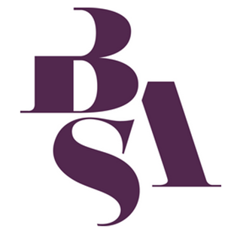
British Sociological Association
Sociology of Religion Study Group
Peter B. Clarke Memorial Prize
Postgraduate Essay Competition 2021

Name

Address

Phone number

Email Address

University/Institution

Programme of Study currently enrolled on

Title of Essay

Word Count

Study Group Member (you must become a member of the study group to enter the competition) | Existing member?  or  Recently joined?  (please tick)

Essays should have their pages numbered and be submitted as a single MS Word document (including this cover sheet) as an attachment to Dr Michael Munnik (munnikm@cardiff.ac.uk)

The closing date for submission is 30 April 2021.

