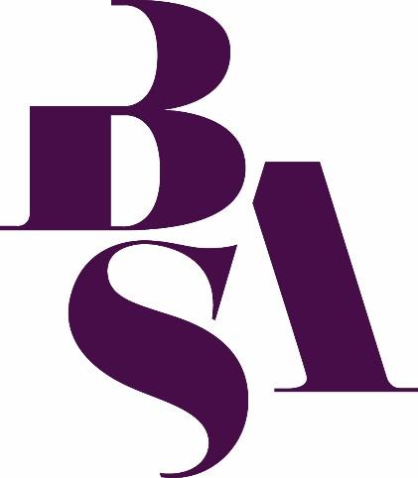

Religion and Power

British Sociological Association Sociology of Religion Study Group Annual Conference

5 July to 7 July 2023
University of Bristol, Bristol, UK

Welcome

We are delighted to welcome you to the British Sociological Association Sociology of Religion Study Group Annual Conference. This year we are excited to be hosting the conference at the University of Bristol.

It is a joy to be able to bring everyone together again, in person, for the first time since 2019. Online technology has provided invaluable opportunities to meet virtually over the past two conference cycles, and opened new possibilities for building our community across future events - but the experience of gathering together as a community in person is something that has been sorely missed. We are particularly pleased to welcome all of those for whom this is their first in-person SocRel conference, especially the many postgraduates and early career researchers presenting and attending for the first time. We hope you feel welcomed and comfortable - let us know if there is anything we can do to help. Whether you are a first timer or have been attending for decades, this is a great opportunity to hear new ideas, be challenged in new ways, and build new relationships. We would encourage you to explore these opportunities over the next few days, whether through attending a paper session on topics outside of your area or speaking to someone for the first time. Most of all, we would encourage you to be welcoming, supportive, and encouraging as we continue to build this academic community.

For this year's annual conference, the theme is Religion and Power.

It is potentially impossible to consider religion apart from power. Religious institutions play an important role in bestowing, legitimising and subverting social and spiritual power. This power has been used both to empower the oppressed and abused to marginalise and silence the vulnerable. Religious movements continuously wrestle with whether and how to uphold, oppose, or stand apart from "secular" power structures. Religious ideology lies behind the "divine right of kings", while also inspiring the powerless, who look to divine assistance for the power to change the world. Religious difference continues to lie at the heart of prejudice and persecution and can even be the trigger for war and genocide, while driving others to stand defiantly in the face of despots in defence of the powerless. Religious believers may see in the transcendent a power that goes beyond all human ability, and may seek ways to encounter and experience this power for themselves; sceptics, meanwhile, may perceive a sedative used by the powerful to keep those they control at bay and limit the true potential of humanity to flourish. As the 21st century progresses, the nature and extent of the power of religion continues to fluctuate, both in Britain and around the world, making the theme as pertinent as ever.

These and other concerns provide the context for the papers presented at this year’s conference and we look forward to exploring them together. Alongside all our delegates we are happy to welcome our keynote speakers - Anthea Butler (University of Pennsylvania), Tariq Modood (University of Bristol), and Lisa Oakley (University of Chester) - as well as our keynote panellists: Dilwar Hussain, Chine McDonald, Tripti Megeri, and Sarah Owen MP. We are also excited to welcome Muneera Pilgrim, who will be providing thought-provoking entertainment for us on Thursday night along with a workshop.

Finally, a special thanks to all who have contributed towards making this conference happen. Firstly, to all of you attending as presenters and delegates. We were delighted to receive so many fascinating abstracts this year and it is great to see such a high number of people coming along to make this conference what it is. At the University of Bristol, Hannah Anderson and Nina Bullock have provided invaluable assistance in helping us to make this event a reality. Thanks also to the team at the Bristol & Bath Convention Bureau in helping us find accommodation options for delegates. Daniel DeHanas has made a crucial contribution not only in helping bring the vision of a politics panel to life but also for introducing us to the brilliant Muneera Pilgrim. Thanks must also go to all of our session chairs, for helping to ensure an environment in which ideas can flourish. Last but far from least, thanks to all those at the BSA who have helped to bring this event to life, particularly to Events Officer Elaine Forester and Events Co-Ordinator Tallulah-Gaze Paddick. Without Tallulah's constant support, creativity, and diligent hard work, this conference could never have happened - it has been a joy to work alongside her.

We hope you enjoy the conference and will return again next year!

Rob Barward-Symmons (SocRel Events Officer) on behalf of the SocRel Executive Committee: Saleema Burney, Ann Gillian Chu, Mathew Guest, Kim Harding, Isabella Kasselstrand, Renasha Khan, Dawn Llewellyn, and Sonya Sharma.

Contents
Welcome 2
Key Information 6
Conference Venue and Registration 6
Transport 7
Food and Refreshments 7
Guidance for Presenters, Chairs, Panel Hosts and Discussants 8
Telephone Numbers 8
Outline Programme 9
Keynote Speakers 10
Keynote 1: Tariq Modood 10
Keynote 2: Anthea Butler 12
Keynote 3: Lisa Oakley 13
Panel - Religion and Power in British Politics 14
Postgraduate and Early Career Workshop: Liam Harrison 16
Abstract Book 17
Day 1 - Wednesday 5 July 17
Parallel Session A - 14:30 – 16:00 17
Exploring the Entanglements of Religion, Education and Citizenship 17
Religion and Social Change 18
Religion, Ethics and Cultural Change 19
Religion, Power and Gender 20
Religion and Work 22
Parallel Session B - 16:30 – 18:00 24
Building Positive Relationships across Religion and Worldview Diversity: Student Life on University Campuses 24
Short Presentation Session 1 24
Religion and Sexuality 27
Religion and Formation 28
Religion, Power, and the State 30
Day 2 - Thursday 6 July 32
Parallel Session C - 11:30 – 13:30 32
Religion, Power and Feminism: Identities in the Field 32
Islam and Education 32
Religion, Materiality and Image 34
Religion, Power and Activism 36
Legacies of Protestant Power 38
Parallel Session D – 15:30 – 17:00 40
How to get Religion Research Published and Funded 40
Religious Identity and Higher Education 41
Religion after Conflict 42
Religion and Social Justice 44
Short Presentation Session 2 45
Day 3 – Friday 7 July 48
Parallel Session E – 09:30 – 11:00 48
The Role of Public Enquiries when Investigating Religion and Child Sex Abuse: Process, Power and Survivors Voices 48
Muneera Pilgrim Special Workshop Session (10:00-11:00) 49
Religion, Power, and Public Health 50
Practices of Secularity 52
Power and Religious Outsiders 53
Parallel Session F – Friday 7 July 14:00 – 16:00 55
Neoliberal Religion: Faith and in the 21st Century 55
Power in Academia 55
Short Presentations Slot 3 59
Salafism and Politics 61

Key Information

Conference Venue and Registration

The SocRel Annual Conference 2023 is being hosted by University of Bristol.

Conference registration can be found in The School of Humanities, Woodland Road, Bristol, BS8 1UJ.

At registration you will be provided with your name badge and the QR code* to access the conference programme. We request that your conference badges be worn at all times for security reasons and the provision of meals. Should you have any queries please ask a member of staff who will be available at the registration desk, or wearing a BSA shirt.

*As part of the BSAs ongoing green initiative, we are moving away from hard copy programmes, although some hard copies will be available to look at whilst you are at the registration desk.

Luggage: On the first and last day, you will be able to leave your luggage in Stenhouse Wing building, room BH05. We will be able to direct you to this room from the Registration Desk.

Please note that any luggage left in the luggage room is the responsibility of the owner and not the SocRel committee, BSA or Cardiff University.

Transport

University of Bristol School of Humanities has excellent public transport links. Details of various options can be found below.

Train: Delegates arriving by train should alight at Bristol Temple Meads Station. You can then choose from any of the options below in order to get to the venue.

Bus: If you are catching the bus then please follow the link below to plan your journey. Most busses in Bristol have on board WiFi and accept card payments. https://www.firstbus.co.uk/bristol-bath-and-west

Taxi:
Bristol Starline Taxis: 0117 313 4884
Veezu Bristol: 0117 925 2626
Zoom Cars: 0117 925 2626

Parking: Delegates will not have access to parking in the University car parks, as this is extremely limited and requires a permit. However, you can find details of car parks here: https://www.bristol.gov.uk/residents/parking/where-to-park-in-bristol

Food and Refreshments

Lunch, tea, coffee, and refreshments will be served in the main registration area of the School of Humanities, on the 5, 6 and 7 July throughout the day.

Evening Dinners on Wednesday 5 and Thursday 6 July

Senate House Marketplace evening meals will be available on the 5 and 6 of July for those delegates who have booked for this optional extra as part of the online registration process. You will receive a token on entry that entitles you to the evening meal, and your choice of either one alcoholic or two non-alcoholic drinks.

Please make your way less than a two-minute walk up the road to Senate House, Tyndall Avenue, Bristol, BS8 1TH, where the dinners will be held. Please ensure that you wear your conference badge at all times.

On Wednesday 5 July there will be Mezze Bowls and an informal ‘pub-quiz’ with prizes to be won! On Thursday delegates will be lucky enough to enjoy an interactive workshop from Muneera Pilgrim, along with Pizza and music. Both these events are informal and intended to promote communication and networking with your fellow delegates.

Guidance for Presenters, Chairs, Panel Hosts and Discussants

Computer stations and linked electronic display equipment will be available for your use. Each room is equipped with computers for presenters and will be running the Microsoft Windows operating system and Microsoft Office software. Please use Microsoft PowerPoint for visual aids. Presenters, Chairs, Panel Hosts and Discussants should attempt to arrive 10 minutes prior to the commencement of their sessions to discuss the running of the sessions and check that visual aids are displaying correctly. Please have your PowerPoint presentation available on a USB flash drive or an online storage space (for example Google Drive) and ensure that you are easily able to locate it. There are connection points available to connect laptops to the display systems, but if you use a Mac, please bring the required cables to connect to a PC as these will not be available at the venue.

Oral Presentations

It is essential that presentations run in accordance with the scheduled times. This will allow delegates to move between presentation rooms during the parallel sessions. We ask that Chairs place due emphasis on the importance of adhering to the schedule in running the parallel sessions. The general expectation of an oral presentation is that a 30-minute paper slot should consist of a 20-minute presentation followed by a 10-minute opportunity to ask questions.

Short Presentations

If you have elected to do a short presentation, you will be in one of the three slots that are highlighted in green. These presentation slots will be a total of 15 minutes. The expectation here is the slot will consist of a 10-minute presentation, followed by 5 minutes of questions.

Telephone Numbers

For conference enquires, the BSA Events Team can be contacted on the following numbers should a member of staff not be available at the registration desk.

- Main office: 0191 383 0839
- Events extension: 0191 370 6633
- Email: events@britsoc.org.uk

In a fire, health or crime related emergency, your first point of contact should be Emergency Services on 999, which is the emergency number in the UK for fire, ambulance or police.

Outline Programme

Wednesday 5 July 2023

10:00 – Registration
11:00 – PGR and ECR drop-in and Welcome to the Conference
11:45 – Formal Welcome
12.00 – Keynote Plenary 1: Tariq Modood
13.30 – Lunch
14.30 – Parallel Sessions A
16:00 – Refreshments
16:30 – Parallel Sessions B
18:00 – Break
19:00 – Informal Dinner at Senate House Marketplace with SocRel Quiz
Cloakroom Times: 10:00 – 18:15
Prayer and Quiet Space will be open from 10:00 – 18:00

Thursday 6 July 2023

08:00 – Registration
08:30 – SocRel Committee Meeting
PGR and ECR Breakfast
09:30 – Religion and Power in British Politics Panel
11:00 – Refreshments
11:30 – Parallel Session C
13:30 – Lunch
13:30 – SocRel Annual General Meeting
14:30 – PGR/ECR Workshop: Liam Harrison
15:30 – Parallel Session D
17:00 – Break
17:30 – Keynote Plenary 2: Anthea Butler
19:00 – Pizza evening at Senate House Marketplace followed by Muneera Pilgrim
Cloakroom Times: 08:00 – 19:15
Prayer and Quiet Space will be open from 08:00 – 18:00

Friday 7 July 2023

08:00 – Registration
09:00 – PGR and ECR Coffee and catch-up
09:30 – Parallel Sessions E
11:00 – Refreshments
11:30 – Keynote Plenary 3: Lisa Oakley
13:00 – Lunch
14.00 – Parallel Sessions F
15:00 – Muneera Pilgrim Special Workshop
16:00 – 16:10 Final Remarks and Conference Closes
Cloakroom Times: 08:00 – 16:30
Prayer and Quiet Space will be open from 08:00 – 16:30

Keynote Speakers

Keynote 1: Tariq Modood
University of Bristol

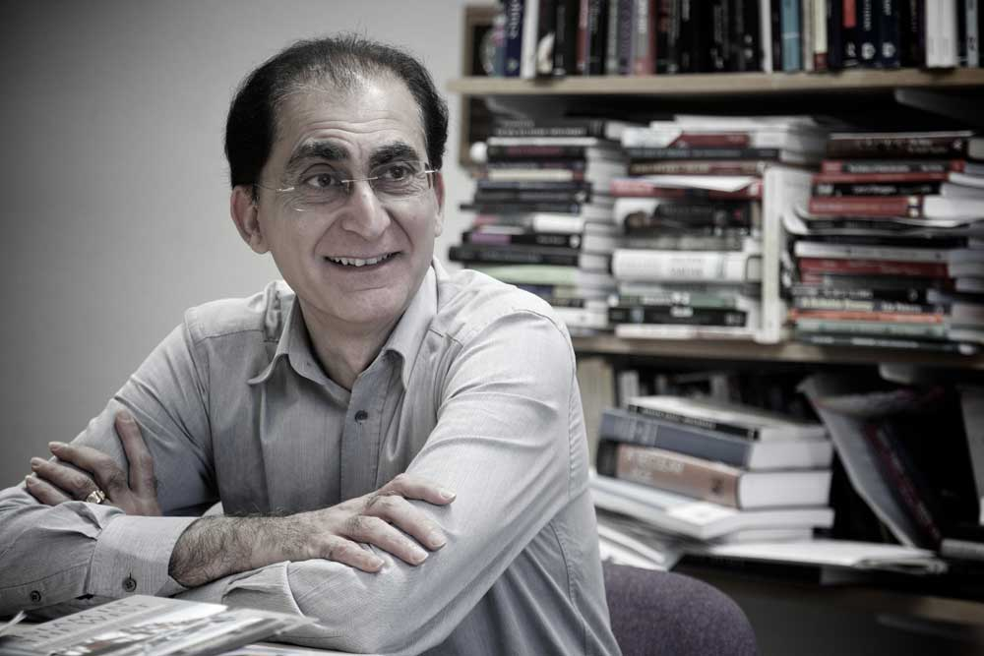

Wednesday 5 July 2023, 12:00 – 13:30 Room B.HO5 (Main Lecture Theatre)

Chair: Mathew Guest

Islamophobia, Antisemitism and the Struggle for Recognition: The Politics of Definitions

Islamophobia and antisemitism are two forms of racism that have much in common. The racialisation targets not just a religion or religious group but what is better understood as an ethnoreligious group. The ways that Jews and Muslims oppose such racism increasingly involves the building up of an identity which, like most contemporary equality movements, does not simply reject the one attributed to them by their enemies but a positive replacement. Such positive conceptions can become oppressor identities, as is the case of certain Islamist identities fostered by the likes of Isis or with a Jewish identity centred on Israel. Moreover, the politics of defining these racisms is tied to competition about anti-racisms prioritisation. This should be based on an empirical evaluation of the scale of the respective racisms (and not on an essentialised hierarchy). Unfortunately, in the case of Islamophobia and antisemitism today, there is a wilful empirical blindness, and the prioritisation is taking place on the basis of which victim group is more influential and has more influential friends. Finally, we must be able to critically talk about groups like Muslims and Jews, about Islam and Israel, without being dismissed as Islamophobes or antisemites. For this to be the case, ‘talk about’ must become ‘talk with’: the character of the criticism must take a dialogical form. I conclude by including a sketch of five tests for distinguishing racialisation from dialogical criticism.

Tariq Modood is Professor of Sociology, Politics and Public Policy and the founding Director of the Centre for the Study of Ethnicity and Citizenship at the University of Bristol and the co-founder of the international journal, Ethnicities. He has held over 40 grants and consultancies, has over 35 (co-)authored and (co-)edited books and reports and over 350 articles and chapters. He was awarded a MBE for services to social sciences and ethnic relations in 2001, was made a Fellow of the Academy of Social Sciences (UK) in 2004 and elected a Fellow of the British Academy in 2017. In 2022 he was ranked in the top 20 UK cited scholars in Politics, Law, Sociology and Social Policy. His latest books include Essays on Secularism and Multiculturalism (2019), Multiculturalism: A Civic Idea (2nd ed; 2013); and as Special Issues co-editor, with T. Sealy, Beyond Euro-Americancentric Forms of Racism and Anti-racism (Political Quarterly, 2022) and Global comparative analysis of the governance of religious diversity (Religion, State and Society, 2022). He has a You Tube Channel and his website is tariqmodood.com

Keynote 2: Anthea Butler
University of Pennsylvania
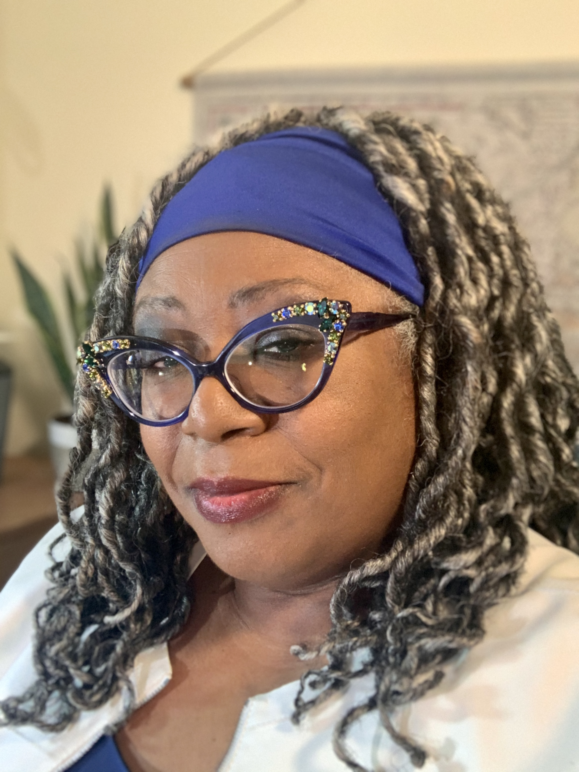

Thursday 6 July 2023, 17:30 – 19:00 in Room B.HO5 (Main Lecture Theatre)

Chair: Saleema Burney

More details to be announced soon

Keynote 3: Lisa Oakley
University of Chester

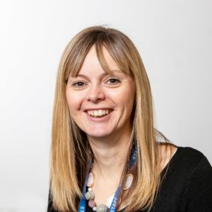

Friday 7 July 2023 at 11:30 – 13:00 in Room B.HO5 (Main Lecture Theatre)

Chair: Sarah-Jane Page

For better or for worse: The use and misuse of power in religious contexts
This paper will draw upon research about spiritual abuse, domestic abuse and disclosures of abuse experienced in religious contexts. The studies used a mixture of methods including narrative interviews, online surveys and photo elicitation. It will also refer to research with safeguarding leads and into safeguarding children and young people in the international Christian context. It will draw throughout on the voices of survivors of harm. The findings of the research will be reflected upon to enable an exploration of the manner in which power and influence operate, the construction of power, and how misuse of power underpins individual experiences of harm and abuse. The paper will draw on work which identifies different forms of power. It will illustrate a range of ways and means through which power and control operate, including the use of scripture, institutional and religious position, enforced accountability, and censorship. The use of these methods to silence those who experience harm and the mechanisms which lead to the protection of institutions over those who experience harm will be reflected upon. The paper will invite delegates to take part in an exercise to critically consider the employment of different forms of power and influence. The paper will briefly explore the inherent power in conducting research and methods to address the imbalance of power. It will close by drawing on research demonstrating good practice, where power and influence have been used to respond well, to protect and to challenge abuse and harm. It will also give examples of responses to disclosures, biblical teachings, and values that participants found helpful. It will argue that it is only through an honest, accessible and transparent discussion of power that institutions can seek to create healthier safer cultures for the future.

Panel - Religion and Power in British Politics
Dilwar Hussain, Chine McDonald, Tripti Megeri and Sarah Owen MP

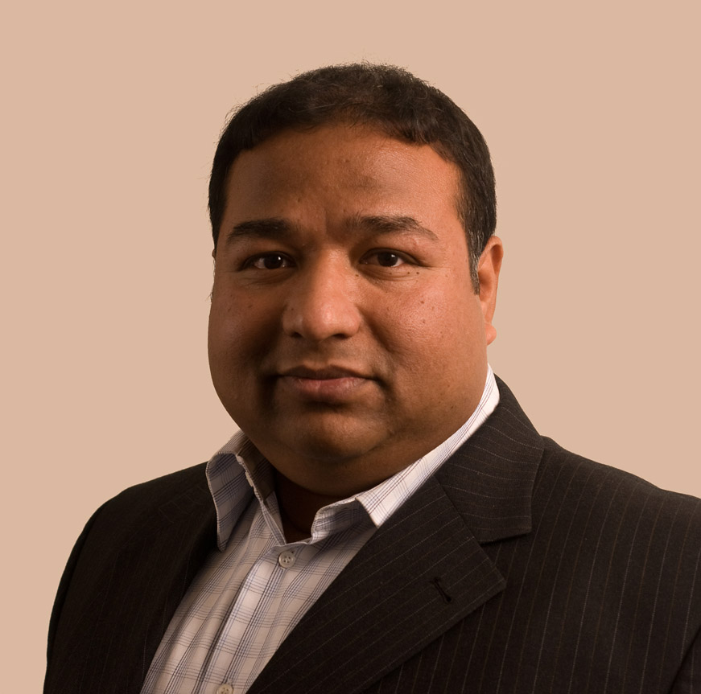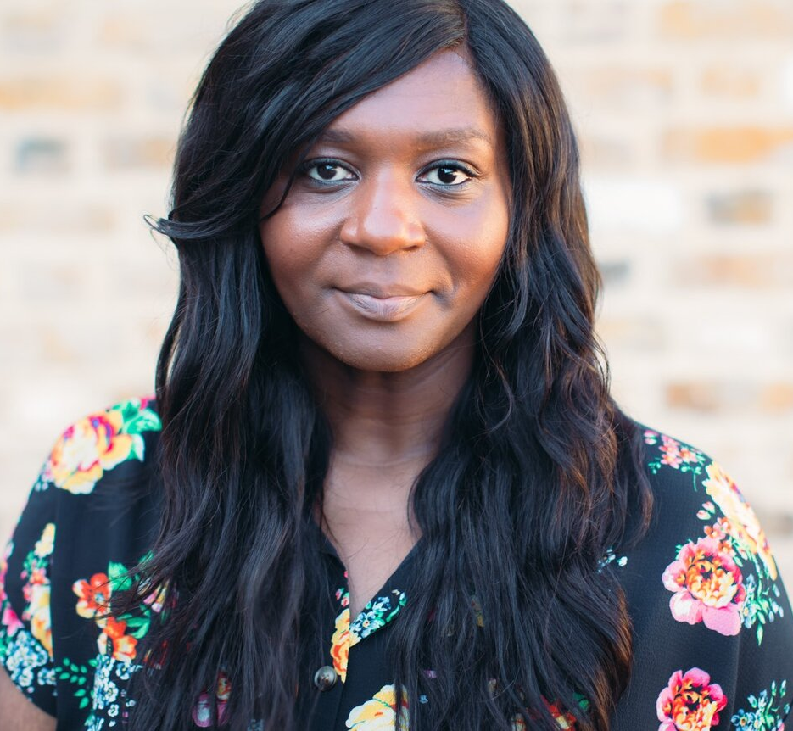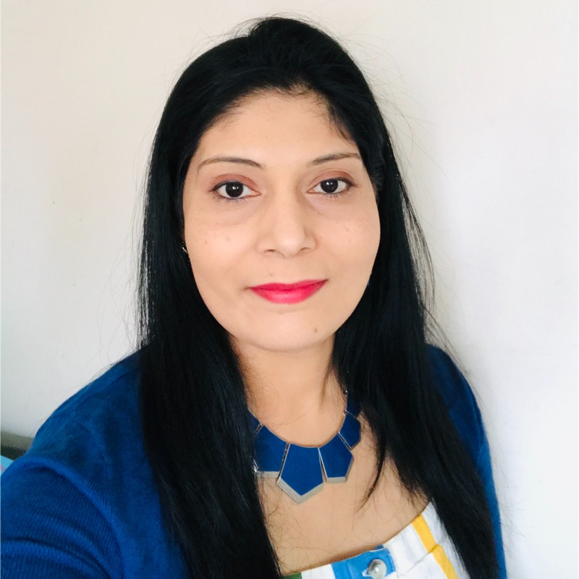

Thursday 6 July 2023 at 09:30 – 11:00 in Room B.HO5 (Main Lecture Theatre)

Chair: Daniel Nilsson DeHanas

Is British politics a setting in which ‘we don’t do God’? This phrase – famously uttered by press secretary Alastair Campbell to deflect questions about Tony Blair’s faith – might be seen as increasingly apt today. After all, the 2021 Census of England and Wales revealed a country that is minority Christian for the first time. Many argue that politics in Britain will be most popular and best functioning when it is thoroughgoingly secular. The 37 percent on the Census who stated they have ‘no religion’ might find religious involvement in politics to be inappropriate, or simply irrelevant. Yet is such a strict division between politics and religion truly realistic? The recent funeral of Queen Elizabeth II and the coronation of her son King Charles III were striking for the central role of the established Church of England in these great ceremonies of state. Alongside becoming more non-religious, Britain is also increasingly multi-faith, due in part to ethnic minority birth rates and immigration. Rishi Sunak (Conservative) serves as the United Kingdom’s first Hindu prime minister. Muslims occupy some of the highest offices in the land, with Humza Yousaf (SNP) as Scotland’s first minister and Sadiq Khan (Labour) as London’s mayor. Bristol, the setting of this year’s SocRel conference, is led by the Jamaican and white mixed-race mayor Marvin Rees (Labour) who is well known for his evangelical Christian approach to politics. This plenary panel will include practitioners from politics and the faith sector to reflect on issues of religion and power, placing emphasis on England and Wales. Some of the issues explored will include the implications of demographic change for the country’s religious settlement, debates on moral hot button issues, and experiences of bringing (non)religious perspectives into the corridors of power. The plenary session will include time for the audience to engage in the conversation.
Panel Participants
Dilwar Hussain is founding chair of New Horizons in British Islam. He has many years of experience working with government and faith leaders as former director of the Policy Research Centre.
Chine McDonald is director of the Christian religion and society think tank Theos and author of the acclaimed book God Is Not a White Man: And Other Revelations (Hodder 2021).
Tripti Megeri is highly active in Hindu and faith-related organisations in Bristol and neighbouring Wales, including serving as secretary of the Bristol Multi Faith Forum and Cardiff director of NWAMI.
Sarah Owen MP has been Labour MP for Luton North since 2019. She is Labour’s Shadow Minister for Local Government, Faith and Communities, and until the end of 2022 served as an Opposition Whip.
Daniel Nilsson DeHanas (panel chair) is senior lecturer in political science and religion at King’s College London and co-editor the journal Religion, State & Society.

Postgraduate and Early Career Workshop:
Liam Harrison

University of the West of England

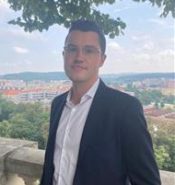

Thursday 6 July 2023, 14:30 – 15:30 in Room B.HO5 (Main Lecture Theatre)
‘We Tell Ourselves Stories’: Research Narratives and Practice
‘We tell ourselves stories in order to live’, Joan Didion famously wrote in The White Album, although the sentiment is prone to being misread. This workshop asks PGRs and ECRs to reflect on the stories we tell in our own research practices, considering selection process, narrative difficulties, and the forms we choose to convey our research. We will discuss the strengths and limitations of established academic mediums – the conference paper, monograph, PhD thesis, etc., and think about what these narratives can and cannot contain. By drawing on a range of creative work – Didion, Rachel Kushner, Roisin Kiberd – this workshop encourages participants to think about the ethical challenges, personal involvement, and storytelling capacities of their research, starting from a literary perspective.
Liam Harrison is a lecturer in creative writing at the University of the West of England, Bristol. He completed a PhD researching late style and modernist legacies in twenty-first century British and Irish fiction at the University of Birmingham. He is a founding editor of the non-fiction literary journal Tolka, and a founding member of the Contemporary Irish Literature Research Network.

Abstract Book

Day 1 - Wednesday 5 July

Parallel Session A - 14:30 – 16:00

Panel Session, Room G.H01

Exploring the Entanglements of Religion, Education and Citizenship

Panel organisers: Anna Strhan and Peter Hemming

The question of how schools should prepare children/young people to be citizens of multifaith societies is subject to ongoing contestation, with religion often politically weaponized in debates about culture and difference. Yet while there have been numerous studies of religion and education oriented towards pedagogical issues such as the practice of religious education, we know little about how religion and citizenship become interrelated in schools, or how power operates in this process. Addressing this gap, this panel brings together three projects exploring how religion, citizenship and values are interrelated, negotiated, and contested in schools.

Education Policy and Youth Freedom of Expression on Race and Faith at School
Karl Kitching, Asli Kandemir, Reza Gholami, Md.Shajedur Rahman

This paper presents an analysis of how education policy, in a context of increased right-wing populism, seeks to contain young people’s ‘free’ public political expression - in particular on race and faith equality issues - at school. The paper analyses almost 80 education policy texts in the English and UK policy context from the 2010-2022 period. We understand ‘free’ expression, e.g., of faith, as discursively constituted rather than existing in an oppositional relationship to power/constraint. Our goal is to unearth not just how freedom of expression is directly defined in policy texts, but also the ways education policy contributes to a political, cultural and affective environment that increasingly constrains the kinds of expression possible for young people in education contexts.

Transgressive Quest/ions? Private deliberations in public disputes over sexuality education in England
Ben Kasstan

Teaching relationships and sex education (RSE) was made a statutory requirement in all schools in England in 2019. This paper draws on long-term ethnographic research to examine how this statutory change is being navigated among Jewish orthodoxies. Diverse claims of transgressing socially-situated approaches to relationships and sexuality were projected by beholders in this public dispute, notably over those with rights to hold knowledge about their bodies and future lives. Institutional attempts to limit knowledge nonetheless launched quest/ions to navigate institutional power, authority and forms of social discipline. Parents felt compelled to conform to institutional positions despite wanting to equip their children with (hetero-normative) knowledge about developing bodies and relations. Religion and power operate across public/private thresholds,but are not without internal critiques of regulatory authority.

Becoming Citizens of 'Postsecular' Britain: Religion in primary school life
Anna Strhan, Joanna Malone, Peter Hemming, and Sarah Neal

This paper presents emerging findings from a three-year study investigating the role of religion in the work that schools do to foster citizenship and national identity, how pupils and parents understand and experience these processes, and what this means for children’s sense of belonging in wider society. Our presentation draws on ethnographic fieldwork conducted in primary schools in four diverse religious/nonreligious ‘microclimates’ in Northwest England, Southern England, Scotland and Wales to consider how regional contingencies contribute to shaping lived religion and citizenship practices, and how this intersects with aspects of class, ethnicity, and race in shaping belonging and in/exclusion.

Parallel Session A, Room G.H03

Religion and Social Change

Chair: Saleema Burney

Building Independent Religious Organization: Women, Power, and the African Methodist Episcopal Church
Jualynne Dodson (Michigan State University)

This paper reports on historical sociological research that conceptualized ‘power’ as the ability to impose ‘will,’ no matter opposition, and viewed ‘power’ as a dynamic, interactive, social phenomenon, not static organizational position. Methodologically, the research was descriptive and analytical, probing thousands of primary and secondary documents from AME individuals, congregations, regional denominational districts’ records, national and international records kept by the Church from its 1787 origins, and more. The paper reports on the first century (1787-1900) of African Methodist Episcopal Church women acquiring and using ‘power’ to impact building of an independent religious organization. African enslavement, sexism, and racism are revealed as contextual global and U.S. social phenomena AME women could not avoid as they encountered them, adjusted, and sustained struggles against the Church’s male-dominated structure. The focus is ‘everyday’ women, as the paper uncovers women’s effectiveness in producing denominational change in authority structure to include women.

Cultivating Virtues for Civic Engagement: Insights from Irregular Filipino Migrants in the U.S.
Jonathan Leif Basilio (California State University, Bakersfield)

This paper proposes the concept of "virtuing" as a framework for examining the motivations and values that underpin the civic engagement of irregular migrants despite the challenges posed by their precarious legal position. The term “virtuing” describes the intentional cultivation of virtues that align with an individual’s legal consciousness and moral aptitudes, highlighting the role of virtues, morals, and religious beliefs in everyday practice. To explore this idea, the paper draws on qualitative data from in-depth interviews with irregular Filipino migrants residing in the United States. From these narratives, it identifies distinct forms that the migrants employ in the course of their civic participation. These include "performative virtuing," which centres on social validation or status; "compliance virtuing," involving a sense of obligation or deference to authority; "reformative virtuing," which coordinates one's legal consciousness with personal moral beliefs; and "subversive virtuing," which entails challenging unjust laws. The paper also emphasizes the role of religion and religious beliefs, as these provide moral guidance and support, in shaping how individuals engage in practices of reformative or subversive virtuing.

Parallel Session A, Room G.HO4

Religion, Ethics and Cultural Change

Chair: Lois Lee

Religious collective memory and trauma in post-communist country
Patrik Polasek (Department of Sociology, Andragogy and Cultural Anthropology, Palacký University Olomouc)

This paper is concerned with the transformation of religious collective memory in the microregion of Eastern Slovácko, Czech Republic. In general, the region of Eastern Slovácko is located in the south-eastern part of Czech Republic and is known for its strong folk and religious traditions. The religious life in the then Czechoslovakia was influenced by the policy of communist regime which was strongly anti-religious. During the research it turned out that this communist disruption is very strong topic. As for religious transmission itself, I examine how religion is transmitted in intergenerational transmission both through collective memory and through social interactions between people.

For the analysis of the disruption I use the concept of collective trauma, which is also closely linked to the concept of collective memory. We can talk about collective trauma when the continuity of collective memory in a certain group is disrupted from the outside. This intervention results in disruption of group consciousness. In my research I deal with this phenomenon because in the past, the communist regime significantly disrupted the continuity of the (religious) collective memory of the Czech nation.

Because collective trauma is one of the sources of generational consciousness and creates specific historical horizon for each generation that has direct experience with the trauma, I focused on the actors' experience of the collective trauma caused by the repression of communist regime, and asking how do they interpret these traumatic events from their generational perspective?

Religion and its power dimensions: Perspective from transient migrants
Lin Ma (University of Bristol)

The modern era witnessed a decline of religion, especially Christianity in the West, from its once dominance of the public order. While states tend to enforce a secular rationale in public space, religious organisations are keen on claiming significance where public services are absent or ineffective. Nevertheless, different power statuses of religions mean that they do not share an equal status in obtaining resources and influencing private lives. This power status of a religion has an institutional dimension. In terms of engaging migrants, power dimensions concern not only this one dimension but also power dynamics between individuals whose racial, national and other statuses may differ, an interpersonal power dimension. This paper adopts a perspective from transient migrants and attends to interactions between ethnic Chinese international students and evangelical Christians in Britain. It contends that without disentangling power dimensions at both institutional and interpersonal levels, we risk reproducing a Euro-American centrism that is biased. This bias manifests a significance of religion by demonstrating what draws people to religion but neglects what drives people away from religion. In the case of transient migrants, people with different trajectories have shared space and conversation in their everyday encounters; their approaches to a religion are rooted in their understanding of power dimensions at institutional and interpersonal levels. Findings from this study suggest that civic nationalism enables religion to maximise its service in public engagement but ethnic disparities intensify religious privileges and disadvantages.

Parallel Session A, Room G.HO21

Religion, Power and Gender

Chair: Sarah-Jane Page

Religious Citizenship: Towards a Revitalised Conceptualisation
Line Nyhagen (Loughborough University)

Religion is a key factor that contributes to the continuation of inequalities linked to gender and sexual orientation around the world, and therefore also to unequal citizenship (Nyhagen & Halsaa, 2016; van Klinken & Obadare, 2018). But while religion can provide limitations and barriers to equal citizenship, it also provides resources and opportunities for everyday citizenship practices including mobilisations for political demands. ‘Religious citizenship’ therefore provides a useful lens on institutional and everyday barriers and opportunities for participation, belonging and inclusion in religious communities and beyond.

Recent scholarship has theorized ‘religious citizenship’ as formal status, rights and duties, and as lived everyday practices. This work also engages with intersectional perspectives, centring on how religion, gender, sexuality and ethnicity intersect in constructions of identities and structures of inequality (Van den Bogert, 2020, Laksana & Wood, 2019; Burchardt, 2018; Chaplin, 2018; Ukah, 2018; Trovão, 2017; Nyhagen, 2015).

The aim of this paper is to achieve a revitalised and innovative conceptualisation of religious citizenship that considers how societal structures and agency are intertwined and the ways in which intersections between gender and other identities and inequalities provide constraints and opportunities for lived citizenship. Informed by feminist theorising about citizenship, the paper proposes that religious citizenship encompasses six dimensions: 1) legal status, rights and duties; 2) participation and inclusion; 3) embodied religious rituals and practices; 4) material resources; 5) emotions in social relations, such as belonging and connectedness; and 6) caring for others and for nature.

Can interfaith work be described as violence against women? - Theorising violence in interfaith work
Suzanne Vernon-Yorke (Coventry University)

Bringing together theories of violence and empirical data generated from 40 semi-structured interviews with interfaith practitioners across three UK cities, with women and men, in equal numbers, identifying as Sikh, Jewish, Hindu, Muslim and Christian, I ask whether interfaith work is not only bad for women, but whether it can be described as violent towards women? Gendered analysis of the data reveals a hierarchy of interfaith work, which privileges men, and often excludes women. This exclusion, evidenced in various forms, when examined alongside the impact of that exclusion, leads to questions of harm and violence. Using theories of violence, I argue that interfaith work is a violent context for women. Using Galtung’s theories of negative peace and the violence triangle, I present the relevance of direct, cultural and structural violence in interfaith work; whilst raising the difficulties of defining and measuring violence, I share some risks of naming it, along with considering the efficacy of doing so.

Submission As Power… Whose Power: Submission Discourse Within African Diasporic Pentecostal Churches in the UK.
Mabel Alkali (Coventry University)

This paper examines the submission discourse within African Pentecostal churches through an empirical study of women within these churches across the UK. Moving away from a focus on the doctrines or sermons of pastors and church leaders, this paper examines the pervasive discourse of submission through the lived experiences and everyday theologies of the women in this study. The paper begins by exploring church understanding of submission and how it relates to the ideal African Christian woman in this context. It then describes the understanding of submission as power by the women in this study and how this understanding is influenced by both secular and cultural context. This understanding of submission indicates the power imbalance inherent in gender relations within these churches, and the subversive effort of the women in this study.

Finally, this paper articulates the use and interpretation of the Bible by church leaders and lay women in understanding submission. I show that submission discourse, whilst it can serve as inclusion for some women, is inherently exclusionary, especially for women who understand submission in a different way because they are seen as deviants by their church community. The findings suggest that there are intersections between, religion, culture, and the secular in creating religious identities. However, a rereading of Biblical texts is needed in developing a more equitable and inclusive theologies in African Christian theologies.

Parallel Session A, Room G.HO29

Religion and Work

Chair: Sonya Sharma

Everyday power in the religious workplace: modest dress codes as gendered aesthetic labour
Reina Lewis, Kristin Aune (London College of Fashion, UAL)

This paper inserts understandings of lived religion into theories of aesthetic labour, bringing the sociology of religion together with the sociology of work and gender to explore how UK women encounter religious dress and behaviour codes in religious work contexts. Studying religion and power in everyday spaces, we compare two very different case studies: women employed by faith-based organisations in the UK and women working for secular organisations who travel for work to Saudi Arabia. Based on data from 65 semi-structured interviews (including wardrobe photographs) we analyse women workers’ experiences in religious contexts as a form of aesthetic labour. Our empirical data excavates the additional aesthetic and emotional labour generated by requirements to create a modest professional appearance, allowing us to map how women navigate and enforce the embodied power relations of the religious workplace. We argue that religion-related workplace modesty codes constitute a religiously-inflected form of organisational aesthetics that may operate simultaneously with, but be experienced differently from, secular-driven organisational aesthetics. Organisations benefit from, but do not recognise or recompense, the additional aesthetic labour that modesty demands of women. Nor do they take into account how workplace modesty impacts on women’s occupational performance. Organisations are also not equipped to conceptualise the impact of modesty codes on women’s sense of self and their belief-based habitus (religious, spiritual or/and secular). Notably, we find that the enactment of workplace modesty is arbitrated by the avoidance of shame; an affect accompanying the government of modesty for all involved.

"It's samSARa, not samsaRA": the Sanskrit language and teacherly authority in contemporary yoga
Samuel Horsley (University of Edinburgh)

Most practitioners of modern postural yoga (MPY) – the practice popularly known simply as “yoga” – are white, non-South Asians who do not identify MPY practice with Hinduism or with religion. And yet, as Lucia (2020) discusses, many seek “authenticity” by appealing to (exoticised) South Asian religious forms, and experience this authenticity as grounds for authority and, implicitly, power. This paper contributes to this discussion through a case study of the use of the Sanskrit language by UK-based MPY teachers, and the affectual experience of authority this usage engenders.

Sanskrit usage represents a fruitful avenue for exploring the dynamics of exoticism, authenticity and authority for two reasons. Firstly, its use in MPY is widespread. Few teachers avoid its use entirely, and many use it extensively (e.g., pose names, Sanskrit text quotations, and mantra recitation). Examining Sanskrit usage therefore illuminates authority dynamics that implicate most MPY practice. Secondly, Sanskrit usage is varied. Divergent priorities and education differentiate its use among teachers, permitting the exploration of a variety of experiences of authority within MPY.

This paper explores three examples of Sanskrit usage among teachers of MPY illustrative of the range of that usage. It uses an analytic autoethnographic method to examine the subjective affectual experience of authority and power in the contexts of Sanskrit usage, from the author’s perspective as both student and teacher of MPY. This research furthers the discussion of the dynamics of exoticism and power within MPY, and contributes to understandings of the affectual experience of (perceived) authoritative speech.

Always somebody else's horizon: Lived religion and the power of work
Mark Read (Unaffiliated)

Max Weber asserted that the modern, capitalist ethic emerged from within the Western, Christian Protestant traditions. These non-conformist religious worldviews, he argued, underpinned rational capitalist expansionism across the globe. Quakers and other similarly dissenting Christian sects were seen as instrumental to the fomenting of these Western modes of industrialised power. Yet, in the early twenty-first century, the tectonics of economic, industrial and technological change has presented Quakers, and perhaps other religious traditions, with a peculiarly contemporary challenge: where lies the boundary now between the ambitions of work organisations inter alia to improve the world, and a religious authority transcendent of the mundane? In the organisational workaday, how heterodox is lived religion and, moreover, who decides?

This paper draws upon qualitative research into Quakers’ experience of the twenty-first century workplace. It argues that Quakers’ religious claims – lived out mainly in services sector jobs – are seen to be aligned similarly with those of the work organisation. At work, Quakers don’t so much contend as blend whilst they mend the world. The liberal Quaker tradition as practice, in this context, appears fundamentally a product – rather than a determinant – of the social particular. Whilst the interviewees aspire to move the world towards a more charitable horizon, today’s work organisation exercises its worldly power to sculpt intimately Quakers other-worldly ends.

Parallel Session B - 16:30 – 18:00

Panel Session, Room G.H01

Building Positive Relationships across Religion and Worldview Diversity: Student Life on University Campuses

Chair: Tim Hutchings

Panel organisers: Mathew Guest, Kristin Aune, Lucy Peacock, Alyssa Rockenbach

Recent debates about inter-religious relations have extended to include engagement between worldviews, encompassing religious and non-religious varieties. One context in which such encounters are magnified is the contemporary university, not least as Higher Education leaders pursue how best to create a positive campus climate, fostering healthy student engagement and mutual understanding while addressing triggers of conflict and intolerance. In the USA, answers to this question were pursued through the IDEALS (Interfaith Diversity Experiences and Attitudes Longitudinal Survey) project, a study that examined the experiences of over 20,000 students who began attending 122 universities as first-years in 2015. By adapting the project for the United Kingdom's higher education sector, IDEALS UK (2021-23) explored through survey and case study research how students’ perceptions of, and engagement with, different campus climates enables or impedes relationships among students of different faiths and worldview perspectives.

This panel brings together researchers from IDEALS and IDEALS UK to explore the project’s findings. Co-PI of IDEALS UK, Professor Kristin Aune will introduce the project, before handing over to other team members to explore the following questions. 1) How do university friendships influence interfaith learning and development?, 2) To what extent does religious education prepare students for interfaith encounters at university? and 3) What relationships exist between students’ interfaith competencies and their university STEM (Science, Technology, Engineering and Maths) studies? Project team members will introduce these themes and outline initial findings from the UK research, before inviting questions, answers and discussion from those delegates present.

Parallel Session B, Room G.H03

Short Presentation Session 1

Chair: Saleema Burney

Change-Making and Leadership among British Muslim Converts
Asma Khan (Cardiff University)

We will present emergent findings from the ‘Transformational: Converts in British Muslim Life’ project, being conducted by researchers at the Centre for the Study of Islam in the UK in collaboration with the Convert Muslim Foundation.

Academic interest in British converts to Islam has been a feature of British Muslim Studies over the last twenty years. Whilst research has tended to focus on processes and experiences of conversion, and on the vulnerabilities and disadvantages faced by converts, our research focuses on their lives post-conversion. We seek to explore if, and how, Muslim converts as change-makers and leaders, from a range of professional and ethnic backgrounds, are transforming religious practices and norms in British Muslim communities, and perceptions of those communities in wider British society.

In this presentation, we will share early findings from this qualitative study to describe the resources (material, social and religious) being mobilised by convert Muslims to enact positive changes in British Muslim communities.

Exploring South Asian Muslim women's experiences of rural green spaces
Mohammed Hamza (Leeds Trinity University)

The body of research investigating ethnic minority people’s experiences in physical activity has grown over the years, yet academia has not yet elaborately addressed their experiences of Rural Green Spaces (RGS). Despite the benefits of engaging with RGS, it is difficult to access for some people to access. This is apparent in inequities of engagement. For example, South Asian Muslim women have been known to be underrepresented as users who occupy RGS. It is argued that more work needs to be done to understand why this is the case, although it can be considered that previous literature has reflected some of the challenges they face in relation to their engagement of physical activity, and wider leisure, due to struggles associated with their identity. This study therefore explored the unique experiences of 23 South Asian Muslim women in England through semi-structured, virtual and walking interviews. The findings are discussed using Bourdieu’s (1977; 1996) analytical tools of field, habitus, and capital. The study presents three key themes of discussion. In these findings the study participants’ heterogeneity in their understandings and experiences of RGS are acknowledged, whilst also recognising the barriers to access they faced and why. The study concludes by recommending future research to better understand the needs of different users prior to the development of policy and practice.

An exploration of the religious nature of Islamic private schools in the UK, What makes a school "Islamic" and why does it matter?
Sulaiman Haqpana (Brunel University of London)

The intersection of religion and education has remained a highly contested discourse, and educational spaces – particularly schools have always played a key role in such interplay. Muslims are by far the largest religious minority in the UK, and the number of Islamic schools has risen sharply (Abram, 2011). Moreover, there is a growing demand for Islamic private schools with a religious focus (Zine, 2008). Although there is a high demand for such schools, literature focusing on their "religious" nature and its effects has been very limited (Shakeel, 2018; Riaz, 2016). The key purpose of this paper is to present a snapshot of Islamic private schools in a way to explore what makes them "Islamic" and why they matter. The study is based on ethnographically informed qualitative research on two Islamic private schools in the United Kingdom. Semi-structured interviews, observations, focused group discussions, and documentary analysis were used as methods for data collection. The key findings of the research suggest that Islamic schools play a vital role in mitigating the power dynamics between secular western society and minority groups through cultural preservation and promoting religious values and ethos to mitigate Islamophobia. Such spaces are also used for political recognition and representation through identity formation. The significance of this research crystallises the importance and the reasons for such a high demand for Islamic private schools in the UK and fills the gap through an exploration of their religious nature and its correlation with discourses such as multiculturalism, secularism, and identity politics.

Getting their foot in the door: Early findings on journalism diversity support schemes and their outreach to Muslims in Britain
Michael Munnik (Cardiff University)

Journalism in Britain is not representative of the population it serves. Muslims in particular are not reflected in the media production industry to the level of either their demographic share or their prominence in news coverage. Scholarly critics doubt that simply hiring a more diverse newsroom will fix problems in the representation of ethnicity, racialisation, or ethnicity and the underlying issues of power (Saha 2018). Nonetheless, social groups pressure news organisations to improve their hiring practices. This process needs to include attention to training, and various groups both within and out with news organisations have developed schemes to support people who wish to train for journalism and don’t fit the typical mould of a UK journalist. In a project funded by the Socrel Seed Corn Fund 2022, I am engaging with some of these groups to understand why and how they encourage Muslims to train for work in journalism. I am interviewing the people who administer these scholarship or grant schemes. I am also interviewing past recipients of funding, asking them to share their motivations for entering journalism training, their reflections on the experience of the training, and what has happened with them since. In this presentation, I share initial findings from these interviews and consider what they show about the relationship between the trainees’ religious identification and their socialisation into a professional habitus.

An Exploration of How Sex Workers Who Identify as Religious or Spiritual Manage Their Identities Within Their Everyday Lives
Daisy Matthews (Nottingham Trent University)

There is a significant gap in the literature on the everyday experiences of religious and spiritual sex workers. My PhD research addresses these limitations by exploring i) what is the relationship between sex workers religious/spiritual and occupational identities and how does this impact their everyday experiences? ii) do religious/spiritual sex workers face identity dilemmas and if so, in what spaces? iii) how do religious/spiritual sex workers negotiate their identities for “harmony” between their potentially conflicting identities? I investigated these questions using participant-driven photo elicitation, diaries, and semi-structured interviews. I will reflect upon these methods as a non-sex worker and elucidate how through adopting a flexible research design, creative methods enable rich exploration of lived experiences.

I demonstrate how religious and spiritual sex workers engage with religiosity in sex work spaces and in their private lives. From my emerging themes, I propose the concept of “harmony” which intends to encapsulate how participants negotiate their different identities to find balance and manage their lived experiences to reduce potential challenges/conflicts. I detail ways religious and sex worker identities can be performed within spaces used for sex work in a harmonious way. This includes how sex workers utilise their religious and spiritual identities to enhance their opportunities for economic income and provide greater experiences of sexual pleasure for participants. My research offers contemporary understandings of religious and spiritual sex workers identity management and I hope to challenge existing stigma against the community through disseminating unique narratives which are disproportionately researched within the academic sphere.

Parallel Session B, Room G.HO4

Religion and Sexuality

Chair: Sonya Sharma

Gender, Sexuality, Science, and Religion: Analysing Power Dynamics in Public Contestation
Rebecca Catto, Rafael Cazarin, Joshua Warren, Mar Griera (Kent State University)

Traditionally scholars of gender and sexuality have not considered religion in their analyses. This has shifted, with sociologists of religion very much contributing to increasing awareness of the significance of religion and belief in relation to gender and sexuality. However, the field of social scientific research on science and religion has yet to take issues related to gender and sexuality into serious account. From emerging analysis of data collected in Spain and the USA - via interviews, focus groups, and media reviews - it is clear that this needs to change and that pre-existing frameworks are insufficient for understanding and analysis.

Based upon a systematic literature review and empirical illustrations, we focus upon the topic of reproductive health and rights to develop new theoretical tools combining work on gender and sexuality and science and religion. Drawing upon Connell’s (1987) concept of “arenas of struggle” in relation to gender and power, this paper presents the concept of the battlefield. In national contexts of political polarization, issues related to gender and sexuality become contested in the public sphere. Both scientific and religious authority, institutions, and discourses are mobilized and sometimes weaponized in such contestations, in a way that directly impacts people’s daily lives. The concept of the battlefield helps sensitize scholars in the fields of gender and sexuality, and science and religion, to how these fields are deeply mutually implicated.

Too Muslim to be homosexual or too homosexual to be Muslim: Belonging experiences of British homosexual Muslims
Stephane Hlaimi (University of Exeter)

LGBTQ Muslims stand at the intersect of two minority groups: the Muslims and LGBTQ community. This paper observes the challenges LGBTQ Muslims face in forming their multifaceted identity and poses the question of how they construct and maintain their LGBTQ and Muslim identities. Using in-depth interviews carried out with British LGBTQ Muslims, we show that LGBTQ Muslims face rejection and identity conflict between their homosexuality and their Muslimness. The opposition between Islam and homosexuality has created for them a feeling of exclusion illustrating, on the face of it, the incompatibility between being Muslim and being homosexual. LGBTQ Muslims face a religiously motivated homophobia that is rooted in the heteronormative precepts of Islam. Whilst in parallel they face Islamophobic attitudes where Islam is now used as a form of civilizational opposition to the British values of tolerance and inclusion and the wider LGBTQ community see it as a threat to their very existence. Nevertheless, the results show that the hostility of Muslims toward homosexuality is evolving, and the heteronormative discourses are now coexisting with more neutral and even homo-friendly approaches. A new bicultural belonging among LGBTQ Muslims is being constructed to address individual strategies of managing both identities and is fostering new interpretations of acceptance of different sexualities within Islam.

Parallel Session B, Room G.HO21

Religion and Formation

Chair: Joanna Malone

“The thing is that there are so many things” - Power and powerlessness in designing UK ordination training
Jennifer Riley, John Swinton (University of Aberdeen)

The number of people living with dementia worldwide and in the UK is growing at a significant rate. Effectively educating future religious leaders to respond to this trajectory is an important step in realising religious organisations’ potential as communities of care and acceptance which can help support the wellbeing of people living with dementia and those who care for them.

This paper draws upon interviews with lecturers at theological education institutions (TEIs) in the UK, representing a range of Christian denominations and churchmanship. Interviews were undertaken to inform the design of educational resources aimed at prospective Christian ministers and leaders, to equip them to undertake and lead future ministry with those living with dementia and those who care for them. The lecturers recognised the importance of education around dementia, and thus of developing such resources. However, the lecturers also articulated a sense of powerlessness: citing limitations in time, expertise and resources, amid an already very crowded curriculum, the lecturers firmly emphasised the barriers to implementing dementia education. In this sense dementia emerged as an indicative issue. The lecturers drew parallels, for example, with educational tools and interventions aimed at: decolonizing the curriculum; improving racial equality in the church; including those with disabilities; and integrating children and young people. As such, the lecturers identified a paradoxical – and somewhat unwelcome – sense in which their powerlessness to ‘cover everything’ highlighted their power over what topics (and, indeed, which groups of people) received attention and inclusion.

On meaning and disciplining: forming the concept of Shabbat as a national holy day in Israel
Stav Shufan-Biton (Bar Ilan University, Israel)

Saturday is the official day of rest for Jews in Israel, and its importance in Jewish religion and culture cannot be overstated. As part of my PhD study, which is based on 66 in-depth interviews with Jews in Israel, I study the social significance of Shabbat and the informal, non-institutional enforcement of its values.

According to my findings, the profound significance given to Shabbat in Israel is not merely a product of Jewish law, but a complex combination of formal and informal processes. On the formal level, the educational system, the media and the law in Israel play an important role in forming the concept of Shabbat, as does the overall atmosphere, repeatedly described as different, thus building up the uniqueness of Shabbat. when all public systems actively work to create "a holy time", characterized by a total separation between the holy and the secular, then, despite the different manners in which the weekend is spent, one can still notice a layer of meaning associated with the "passing of time", infiltrating to all perceptions of this timeframe.
These perceptions continue to strengthen the significance of Shabbat in the non-institutional level, and this general feeling acts "bottom up" in creating concepts of Shabbat that independent of the national or formal views. therefore, despite Jewish law being fully adopted by specific groups among the Jewish society in Israel, it appears that the cognitive time views of this weekend timeframe have a much broader effect on the various ways it is spent.

Embodying the Legacy of Catholic Church: the Experience of Yoga Practitioners in Ireland
Sophia Martina Pallaro (DCU)

Until recently in Ireland the Roman Catholic Church has occupied a position of dominance not only in the religious sphere, but also in other social fields, particularly the State, family, education, health, and social welfare (Inglis 1998). In the mid-1990s Ireland saw a sharp decline of trust and confidence in the Church and religious organisations. This was the result of social and cultural changes brought by the economic boom of the Celtic Tiger, and significantly, of the scandals of systemic abuse of women and children, and the discovery of the cover-ups by the Catholic Church. This paper explores how the cultural trauma (Alexander 2004) left by the Catholic Church, part of the collective memory and identity of many Irish people, becomes manifest in the embodied experience and narratives of yoga practitioners in Ireland. Paradoxically, when first approaching yoga, which is often thought of as a freeing and liberating way of experiencing one’s body and spirituality, Irish practitioners can find their embodiment constrained by the cultural legacy of the Catholic Church. Overtime, practitioners’ experience is transformed and the body, once a source of shame and a locus of control of the Catholic religion and culture, becomes a source of awareness and connection. This, in turn, provides new narratives to understand and make sense of religion. To this extent, a sustained engagement with yoga can provide a repertoire to navigate, negotiate and transform the legacies of Catholicism, and Catholic power, practise and culture.

Parallel Session B, Room G.HO29

Religion, Power, and the State

Chair: Lois Lee

Power and Authority in the Sharia Council Debate in the UK
Fouzia Azzouz (University of Algiers II)

In this presentation I draw on various empirical studies, including my own, to explore the phenomenon of Sharia councils in Britain and their perceived authority as community quasi-judicial mechanisms in the area of family law, and more specifically marriage and divorce. I will highlight the kind of power that Sharia councils have to either empower or oppress Muslim women users seeking divorce. Further, I will look into instances where the authority of these mechanisms and their scholars is contested by men and women users. From a service-provider perspective, I explore the demand for and rationale behind using the services provided by these mechanisms and the perceived role and authority that faith-based community mechanisms exercise on their users and the larger Muslim community. From a service-user perspective, I look into the kind of interactions that take place during Sharia council meetings with users and the latter’s engagement with and responses to the council’s final decision or religious ruling, which can often include conflict and disagreement. I will highlight how service providers, by appealing to the higher objectives of the Islamic faith, maintain a strong claim of moral responsibility for the work that they engage in and how they are motivated to fill in a perceive gap in the British Muslim community with regard to the issue of granting religious divorces. On the other hand, women’s experiences as service users emphasize a logic of pragmatism in their engagement with Sharia councils and their decisions, sometimes contesting the latter and pursuing further alternatives or what is known as ‘forum shopping’ in order to meet their needs.

The religious imaginary and the oppressive state: Ukrainian and Lithuanian scientists born in the USSR
Maria Roginska (Institute of Philosophy and Sociology, Pedagogical University of Krakow)

The paper explores political and normative aspects of the Soviet atheistic regime that contributed to the formation of the religious imaginary of believing Ukrainian and Lithuanian scientists born in 1930-1960s. After the collapse of the Soviet Union, most of them did not accept Orthodox, Catholic or other institutional religions, but instead created their own privatized religious patterns, using science-related elements in their imaginary. This distinguished them from the other national groups participating in the study. In the paper I propose an interpretation for this phenomenon. I analyze 29 in-depth interviews of a larger sample and focus on the biographies of the older cohort of natural scientists from Lithuania and Ukraine to show how the Soviet political and normative context supported their science-based imaginary.

Well-being in Sufi collective and individual practices: How does Sufi spirituality develop the individual's resilience during the grief and Bereavement process?
Merve Cetinkaya (University College London)

This paper aims to present the role of Sufi practices in the well-being of regular members of Sufi gatherings in London. It is framed by the secularisation thesis and the distinction between spirituality and religion alongside the well-being effects of the practice/rituals. This is used to examine the role of well-being in collective and individual practices. The paper investigates the factors and reasons individuals participate in religious/spiritual practices and how the broader social, religious, and mental contexts impinge upon their experiences. Qualitative interviewing and focus group discussion have been used to collect data from the individuals' experiences. Qualitative data identified two main domains, identity (sense of belonging) and Social Support (having a trustful and supportive community). The religious/ spiritual gathering positively impacts the individuals' general well-being, especially during grief, bereavement and breakdown. It also provides a power to develop resilience towards the hardship of their lives.

Day 2 - Thursday 6 July

Parallel Session C - 11:30 – 13:30

Panel Session, Room G.H01

Religion, Power and Feminism: Identities in the Field

Chair: Sonya Sharma

Panel organisers: Saleema Burney (Birmingham University), Renasha Khan (Kings College, London), Lois Lee (University of Kent), Dawn Llewellyn (University of Chester), Sonya Sharma (UCL)

This panel continues the significant conversations emerging from the ‘Feminist Identities in the Field’ roundtables at SOCREL in 2021 and in 2022. The first discussed how feminist interventions in the sociology of religion shaped contributors’ fieldwork and identity but -- as audience members highlighted -- the discussion was unreflexive about whiteness and the prominence of ‘secular’ and Christian research sites. The second panel invited conference delegates to participate, and their commentaries identified how race, class, and neurodivergence inflected their identities as feminist researchers in gender, sociology, and religion, and critically reflected on the intersectional structures that have formed the discipline.

This year, we invite conference delegates to participate in an interactive workshop to trace the dynamic relationship between religion, gender and feminism. Participants will be asked a series of orientating questions for small group discussion about the complexities of taking power and representation seriously in the study of religion and gender. We hope to raise challenges, ask new questions, return to long-standing issues that perpetuate inequalities, and consider answers to pressing problems that linger in the discipline, the academy, and the public sphere.

Parallel Session C, Room G.H03

Islam and Education

Chair: Michael Munnik

Power Relations and Knowledge Distribution in an Islamic Educational Institution in India: An Analysis of Textbooks and Curriculum
Mahak Mahajan (Indian Institute of Technology, Mandi, Himachal Pradesh, India)

It is always inferred that the knowledge provided in the madrasas (Islamic educational institutions) is religious in nature, especially in the post-9/11 period. The paper aims to understand how religious knowledge is constructed through social, cultural, political and historical transformations happening in society. For the purpose of this study, the textbooks and curriculum of a girls’ madrasa located in Jammu, Jammu and Kashmir are evaluated. The girls’ madrasa under study follows the Deoband school of thought (an Islamic revivalist movement that started in colonial India in the 19th century). The main focus of the paper is to understand that the content and knowledge of religious education are very much embedded in social, cultural and political processes that take place in society over a period of time. The paper highlights historical and ideological struggles during the establishment of Deoband madrasa in the 19th century and its influence on the production of knowledge and power relations. The paper also takes into account classroom teaching to understand the teacher’s viewpoints and hence the interpretation of the text, which in turn impacts the socialization process of girls and helps us in delineating the links between community identity and education. Textbook knowledge and choice of the curriculum aid to consolidate group representation and the identity formation process. The paper also brings to light how Muslims are making sense of their identity and asserting their position in society.

Young Muslims and the 2019 Relationships and Sexuality Education Birmingham Schools’ Protests: Missing Voices from the Debate
Sarah-Jane Page, Celine Benoit, Fida Sanjakdar, Pam Lowe (Aston University)

In recent years, the development of relationships and sexuality education has been fraught with controversy, especially regarding the development of a more inclusive curriculum (e.g., addressing same-sex relationships). Birmingham, UK, was the site of such contestation in 2019, when the use of curriculum materials (the No Outsiders programme) led to direct action at schools (including a petition, school gate pickets, and withdrawing children from class). While the parents involved argued that the programme was against Islamic values (Sanjakdar 2021), teachers and school leaders faced dilemmas regarding how to follow the law while avoiding further dissent. These issues are refracted in broader debates regarding the positioning of Islam as a ‘problem’, with the hypervisibility of the schools’ protests used as a mechanism to further scrutinise Muslim communities (Khan 2021). Yet one key constituent at the very heart of the debate – young Muslims themselves – were absent from the discussion. This presentation will detail data gathered from two sources between 2022 and 2023: interviews with those directly impacted by the schools’ protests (e.g., teachers, residents, parents) and a specific focus young Muslims (aged between 16 and 20) who reflected both on the consequences of the protests and on what they wanted from the relationships and sexuality education curriculum. Typically, they problematised the protests and parental interference, yet also wanted curriculum adjustments. The insights of young Muslims and their lack of voice in this debate give crucial insights into power dynamics and authority in the sphere of religion, sexuality and education.

Experiences of islamophobia, hypervisibility and secular normativity: Muslim students in superdiverse Swedish high schools
Christopher Thoren (Gothenburg University)

This paper examines the experiences of Muslim students in relation to Islamophobia, secular normativity, and hypervisibility within education. Ethnographic fieldwork was conducted at a high school in a Swedish superdiverse area where many students identify as Muslim. This area is characterized by low-income levels, high unemployment rates, and low school performance rates. Despite extensive previous research on inequity in Swedish schools, an examination of how inequity plays out in relation to belonging to a religious minority is seldom part of the analysis.

The notion of Islamophobia is used to theorize the racialization of Muslim students in relation to education, place, and stigmatization. In analysing Islamophobia, an intersectional approach is crucial as students' vulnerability is manifested through different and simultaneous processes of power. The strong secular normativity that can be found in Sweden contributes to a situation where seemingly neutral attitudes towards religion can be experienced as discriminatory and invisibilising of religious minorities. In a seemingly paradoxical way, Muslim students also inevitably become hypervisible and encounter unwanted comments and experiences that certain religious practices evoke strong reactions from those they encounter. This leads Muslim students to feel compelled to hide parts of their identity.

The analysis suggests that Muslim students feel unable to fully express their Muslimness or be a part of the school community on their own terms. However, they also develop strategies to avoid vulnerability and navigate the school system to find schools where they can create safe spaces and focus on their studies.

Strategic adaptation by Muslim Schools in Responding to Shifting Social and Political Contexts in Kashmir: A case study
Insha Riaz Factoo (Tata Institute of Social Sciences)

This paper examines the changing vision of Kashmir Memorial School (name changed), which was established with an inclusive mission to include children of families which were dissenting and non-conformist towards the conventional Christian missionary schools in Kashmir for multiple reasons. Religious factors played a significant role but challenging the political and ideological status quo by refraining from sending their children to attend schools which for them meant not just confirming to the establishment but also de-prioritizing their local school system. What happened that transformed Kashmir Memorials Vision? This paper looks at the role of strategic adaption in responding to shifting social and political contexts. Drawing on interviews with teachers’ ex-students’ administrators, as well as analysis of policy documents and quotidian experiences of ex-students, the paper explores how the school has evolved in response to changing demands and challenges. We argue that the school’s success in navigating these challenges can be attributed to its ability to strategically adapt its vision and practices, while remaining grounded in its core values and mission. We also consider the potential risk and trade-offs of strategic adaption, including potential for mission drift and loss of community support. Ultimately, we conclude the paper with two questions and scope for further enquiry on Kashmiri schools. Do we look at this as Epistemic Violence? How significant is it for a place like Kashmir which has been facing political subjugation for decades, to have institutions that recognize dissent and play an important role in cultivating counter-narratives?

Parallel Session C, Room G.HO4

Religion, Materiality and Image

Chair: Tim Hutchings
Constructing Transgressive Image: The Exclusion of Certain Religious Practices Being Labelled as Xiejiao (邪教) in China's Public Administration
Chunrong Zhao (Utrecht University)

The transgressive aspects of religions have been a persistent concern in the sociology and anthropology of religion. For a long time, however, academic discussions of the transgressive aspects of religion have been limited to the transgressive ‘essence’ of the religious practice itself, whereas neglecting the constructiveness of the social context in which the religious practice in question is embedded, as well as the role of power behind it. Conventional perspectives tend to take the transgressiveness of religious practices for granted as if they are inherently transgressive. However, a religious practice being regarded as transgressive is based on the gaps, contradictions, or even oppositions between this religious practice and the social expectations, social tolerance, and social conventions of the society. Therefore, the dynamics of the corresponding social context is also an indispensable aspect that should not be overlooked in the discussions of religious transgressions.

This paper aims to break away from the traditional static understandings of the transgressive aspects of religion and focus on how power shapes social opinion, expectations, and even norms, thereby establishing and reinforcing boundaries and constructing the transgressive image of particular religious practices for the purpose of ideological propaganda. Taking the phenomenon of Falun Gong in China as an example, this paper analyses how the Chinese authorities, by labelling certain religious practices as ‘xiejiao’ (literally meaning ‘evil cult’), manipulate social opinion and establish atheistic/anti-religious norms to stigmatize and exclude the practitioners in public administration and to justify the persecution against them.

Communicating human solidarity through sacred topography: Ukrainian Via Dolorosa art exhibits at Meersel-Dreef
Nidheesh Joseph (Indian Institute of Management Tiruchirappalli)

Fourteen Via Dolorosa art exhibits juxtaposed with the Ukrainian refugee suffering drawn by a priest in Meersel-Dreef (Antwerp, Belgium) Catholic monastery to express solidarity with the suffering of the Ukrainian refugees in February 2022 are the focus of this paper. This paper explores how visual art documenting human suffering aid in mobilizing humanity against war and its devastating consequences. These art exhibits were created by the priest while caring for the Ukrainian refugees in the initial days of the war. Though the refugees returned shortly, the exhibits continued to talk to the community in Meersel-Dreef and in different parts of the world. Although largely overlooked as a sacred topography, the Via Dolorosa showcases the intensity of violence which is still relevant in today’s war-torn world. The art exhibits used the paradigm of the fourteen stations to contextualize themes that are unrelated to the life of Jesus but highly significant to gospel values. This paper discusses the ways in which these art exhibits bridged the gap between the religious and secular worldviews in the post-secular age. In doing so, it calls for a recognition of the role of artists and relief workers in sustaining post-war visual discourses of war and its negative consequences. The article offers fresh insights into the ethical representation of distant human suffering, the communication of human solidarity through sacred art, and the contribution of visual artists to post-war healing and reconciliation.

Parallel Session C, Room G.HO21

Religion, Power and Activism

Chair: Anna Strhan

Does being public give us power? - The interpretation of two religious environmental movements about the relation between power and the public
Vancso Anna (Eötvös Lóránd University)

There is no doubt that religion has a strong power in shaping people’s view about the world in every sense. How should it be structured, how should people live in it, what are the rules and boundaries, or what are the aims and roles of people in the world? It can play an important role in transmitting and legitimating the status quo as well as be a catalyst for social change. Religious movements can fight against social inequalities, existing political power or climate change; but for reaching their goals, visibility in the public sphere is essential. Today’s climate change movements are quite loud and publicly noticeable, their power partly lies on their presence in the public.

In my research I aim to understand the lack of strong public presence of two Hungarian religious environmental movements – one belonging to the Hungarian Reformed Church named Ökogyülekezeti Műhely, the other an ecumenical movement, Naphimnusz Teremtésvédelmi Egyesület – by investigating their interpretation of the connection between power and the public concerning climate change, but also to understand why in case of actions for social change and solidarity these movements are invisible. I use both questionnaires and semi-structured interviews with the leading figures of these movements to answer my questions. I argue that beside the effect of the political context, their understanding about the public and the power of being visibly active vastly differ not only from non-religious climate movements, but other forms of religious movements fostering social change.

Capital and Power in Islamic Banking and Finance
Muhammad Zulkifly (Durham University)

The advent of Islamic banking and finance (IBF) has presented an opportunity for not just the Muslim community, but also others, to experience the principles of the Islamic moral economy. However, this has also resulted in the creation of a new sphere of influence, dominated by the power wielded by the financial industry. In other words, this space is now inhabited by Shariah scholars who serve on the Shariah boards of financial institutions. Prior to the establishment of IBF, the role of Shariah scholars was limited to religious institutions such as mosques, and they had no intersection with capital in their domain.

However, with the influx of capital, the need for Shariah scholars to legitimise the movement of capital has become pressing. The power to legitimise, however, can be perceived as instrumentalising religion for personal gain. The Islamic moral economy teaches that the source of legitimacy is derived from a single "ifta" institution, which is a body responsible for issuing legal rulings. However, with the development of IBF, the transformation of the source of legitimacy towards individual Shariah scholars indicates a concentration of power at the individual level. This paper aims to evaluate the historical transformation of the legitimising actor and its impact on the authentic study of the Islamic moral economy. One of the core principles of the latter is that the accumulation of power can be destructive, as even the Prophet of Islam himself did not accumulate power.

Divine Intervention and Collective Resistance: deity traditions in Kullu, India
Ishita Mahajan (School of Divinity, University of Edinburgh)

In the predominantly rural Kullu district in the North Indian hill-state of Himachal Pradesh, most villages have presiding deities who are viewed as rulers of their predefined territories. Managed by a temple committee, many of these deities are officially recognised as land-owning ‘perennial minors’ by the district administration. The deities speak through their mediums and move across their territory through chariots. They actively use their authority to govern their followers and influence their everyday lives. In the context of Kullu, the deities’ presence actively regulates the State’s authority by challenging its decisions that threaten to interfere with the existing traditions and practices. The 2014 ban of ritual sacrifice, and a more recent case of COVID-19 restrictions on deities’ rituals are some cases where the government has backtracked after facing opposition from the deities and their followers.

Drawing from my fieldwork conducted in 2021-22, I aim to discuss the interdependent relationship between the deity and the village community and argue that the deities act as decentralising forces within the State-subject power dynamics in Kullu. In the current socio-political landscape of India where the State actively silences any narratives that threaten to disrupt its authority, the deity can present an effective vehicle for staging collective resistance. It offers a confrontational mechanism which acts through the largely ungovernable act of divine intervention. I will also attempt to address the power hierarchies operating within the village community itself to explore whether resistance, even if collective, can be egalitarian.

Gaining power? Muslim female activists in Israel
Salwa Alinat-Abed (Open University/Israel)

This lecture deals with female activists in the Islamic movement in Israel and their attitudes toward the Israeli authorities and Israeli culture. The complex Muslim existence in Israel raises questions such as: What is the Muslim activists’ view of the Israeli space? How do they live as Muslims in a non-Islamic space? What strategies do they use to bridge the gap between their religious and civic identities? And how did those strategies help them gain social and political power in the general Israeli circle and the Arab-Palestinian society`s circle?

The lecture presents three leading positions of women activists concerning the Israeli space. The majority want to integrate into Israeli society, while a minority reject Israeli society and want to seclude themselves in a community of an Islamic nature. The third group takes a humanistic position, which emphasizes the person and not their religious identity. The activists prefer not to emphasise their religious identity in the Israeli space, partly because they fear expressing criticism towards Israeli society, assuming that it will lead to persecution and conflict. Female Muslim activists used four strategies: musayiarah (matching), tawriyah (hiding), hasanah (immunity) and muqawamah (resistance) to deal with the Israeli space. These strategies reflected their understanding of the practical meanings of two terms in the Islamic faith, wala’ (loyalty to Islam) and bara' (rejection), that shape the relationship between Muslims and non-Muslims.

Parallel Session C, Room G.HO29

Legacies of Protestant Power

Chair: Rob Barward-Symmons

Pushing the Divine On-Line: An analysis of Mormon authority on the official website of the Church of Jesus Christ of Latter-day Saints
David Scott (Utah Valley University)

Although religious organizations are increasingly turning to the Web to attract followers, doing so is fraught with risk (Dawson & Cowan, 2004). The Internet “poses a radical challenge to the restrictive control imposed by [church] leadership” by allowing communities to converse outside the vertical channels imposed by leaders (Barker, 2005). Online forums also allow detractors or the uninformed to challenge church authorities (Dawson, 2000). However, a recent review of 109 studies of online religion found that only nine examined the relationship between discourse and religious authority (Campbell, 2012).

Using the four authority types recommended by Campbell (hierarchical; structural; ideological; and textual), this paper applies a close-reading of the lead pages and doctrinal claims of the official webpage of the Church of Jesus Christ of Latter-day Saints (“Mormon”). The Church’s website is particularly ripe for analysis as the church president has, in his five years as the Mormon prophet, made significant changes to the faith (including rejecting the term “Mormon” and restructuring and renaming the church’s website) while at the same time highlighting his prophetic authority and “revelation” guiding his actions (Riess, 2022).

This study demonstrates that hierarchical and structural authority appeals dominate the church’s website emphasizing the authority of the highest members of the church’s leadership, even on the more mundane subjects.

The Power of Fandom: Hillsong, Cool Christianity and Young Brazilians
Cristina Rocha (Western Sydney University)

Here, I investigate the ways in which the Australian megachurch Hillsong generates fandom among young middle-class Brazilians. Hillsong embraces Cool Christianity, a style of Pentecostalism that appropriates elements of secular youth cultures. It does so in order to make Christianity relevant to new generations, particularly middle-class youth. Established in Australia in 1983, Hillsong has ‘planted campuses’ in most global cities in the past two decades. The music of its award-winning worship bands is sung weekly by an estimated 50 million people in 60 languages. Hillsong’s pastors have become celebrities in their own right. Here, I am interested in how the Hillsong style creates a fan community connected by affect. I argue that, for young Brazilians, Hillsong and Australia become places and forms of authority. They exert power and offer hope and optimism as paths to change their lives. This is so because in young Brazilians’ imagination the Hillsong’s style and the church’s origins in the English-speaking Global North, a site of modernity, are deeply intertwined. In their desire to travel to Australia to join Hillsong, young Brazilian fans dream of a life that can be ‘otherwise’ – where they are fluent in English, have friends from all over the world, and feel that they belong to a kind of Christianity that is modern, successful, sophisticated, and cool. This contrasts with the aesthetics of Pentecostalism in Brazil, a religion that has traditionally appealed to the poor in the peripheries of Brazilian cities.

Religious Interventions: Religion and Power Dynamics in the Bible Belt
Terry Shoemaker (Arizona State University)

This study, based on qualitative research and participant observations conducted over five years, investigates the social dynamics of leaving white, Christian nationalist communities in the region known as the Bible Belt in the United States. Empowered through the Trump regime, ethnonationalist ideologies continue to influence American political discourse, and a key cultivating space for religiously grounded and racialized Protestant communities across the country containing high percentages of adherents, or sympathizers, to Christian nationalism. Although social scientists are currently attentive to white, Christian nationalism, there is little work investigating what it looks like sociologically to leave these religious communities and reconstruct life and faith that interrogates the inherited racialized power and influence. After establishing a context for this research, which demonstrates the power and authority structures existent for many growing up within the Bible Belt, I focus my attention on the family realities of leaving a white, Christian nationalist community. Leaving includes loss of employment, religious interventions, and intense family pressures. As will be seen, disputes about culture war issues result in spiritual kinship fractures and create competing notions of how life should be lived due to a rupture in the shared “interpretive sociality,” a term I use to describe the everyday pressures and expectations adopted by many Protestants in the region. Ultimately, this study illustrates the ways in which religion operates with a power over individual members and attempts to maintain that power even when an individual decides to depart.

Navigating Religious Authority: LDS Women and Creative Agency
Christine Ten Bosch, David W. Scott (Utah Valley University)

Power studies at the cross-section of gender, religion, and culture provide insight into the complexities of the human experience. Rooted in Foucault’s treatment of power as meaning-making, this research focuses on the action of authority in women’s religious lives. Women in The Church of Jesus Christ of Latter-day Saints (LDS or “Mormon”) may offer a unique perspective on power dynamics vis-a-vis religiosity given that they belong to a highly patriarchal and structured denomination led solely by men.

Traditional feminist research approaches women, authority, and religion through a paradigm of oppression and resistance that limits women’s agency. In contrast, our approach builds on the recent feminist scholarship investigating religious women through a creative agency lens. This study examines LDS women’s participation with, and response to, authority as a feature of their lived experience. The researchers conducted interviews eliciting oral histories of ten LDS women in an effort to tease out the manner in which they negotiate their identity and power within the faith.

These study participants offered varied strategies of maintaining their authority and presence in both the public and private spheres—with many expressing the struggle in negotiating their place within the institutional, textual, cultural, and transcendental space. They typically saw themselves as primary meaning-makers (authority) as they encountered and dealt with tension and conflict between external religious authorities and their own experiences. Our research recognizes that religious women, even in a heavily patriarchal faith tradition, act as creative agents while practicing their faith.

Parallel Session D – 15:30 – 17:00

Workshop Session, Room G.H01

How to get Religion Research Published and Funded

Workshop organiser: Abby Day (Goldsmiths University of London)

Most journal articles and funding research proposals are rejected. That represents a waste of everyone’s time, energy and spirit, especially now when, more than ever, academic careers are precarious.

This presentation covers both publishing and funding challenges in similar, yet distinct ways, focusing on helping people overcome some of the most common obstacles to successful publication and funding. Lack of time? Conflicting priorities? No idea where to start or what matters most?

Based on original research with editors, funders, and successful academics, plus two decades running international workshops on publishing and funding, this presentation shows new and established academics how to identify a suitable publisher and funder, how to plan, prepare and compile a paper or proposal that will satisfy their requirements, how to engage with editors and funding directors, and how to publicise the work and manage often precarious academic careers.

The workshop also addresses the long-ignored ‘elephant in the room’ about the ethics of publishing and funding. Questions are being asked throughout the academy about how the knowledge we produce can be ‘decolonised’. This workshop acknowledges those issues, highlighting areas where publications and funding experiences are unequal and how some people are trying to address this.
Prof. Day's previous career was as an editor and marketing director in academic publishing. Author of two books on publishing and funding, she is Executive Editor at the Association for the Sociology of Religion, and has served as Trustee/Publications Director of the BSA and Sociological Review.

Parallel Session D, Room G.H03

Religious Identity and Higher Education

Chair: Mathew Guest

Christian postgraduates as an invisible minority
Szilvi Watson (University of Oxford)

Higher education was traditionally Christian in England for almost 80% of its history, from the founding of Oxford to the founding of UCL in 1826. In the last 200 years Christian students have gone from complete hegemony to a significant minority, and today 25% of postgraduates identify as Christian. Through the same 200 years, the student population has exploded, bringing postgraduate numbers to 600,000. Their experiences are under-researched, and even less is known of their religious experience.

Whilst Christian students have been grappling with the secularisation of academia for decades, the Equality Act 2010 and the influx of international students has brought about a shift and institutions started to pay attention to the needs of religious students in recent years. Paradoxically, Christian students feel further disempowered as the practices of minority religions are being publicly recognised but Christian traditions are fading out, or some of them say, are being phased out. In the meanwhile, the present decolonisation discourse may also project assumptions on Christians.

Through a small-scale MMR study of the Christian postgraduate experience at secular universities in 2022 I found that whilst leaders sense a change in the attitudes of the university through EDI policies starting to be expanded to religious students, Christian postgraduates do not (yet?) feel this on an everyday level. I draw on interview excerpts and survey results to illustrate the triple challenge of secularisation, ‘historical baggage’ and being an invisible minority, while highlighting that to many students having faith is helpful in dealing with these challenges.

Religion, power, and the strategies of Catholic universities: competition of institutional logics between formation and adaptation
Marcin Zwierzdzynski, Dariusz Szklarczyk (AGH University of Science and Technology)

Catholic universities operate at the intersection of various institutional logics that represent the dispersed power in organisations. They are subject to both state and church law. They follow global science trends, such as improving the quality of research and teaching, internationalisation or interdisciplinarity. At the same time, they are subject to market logic, which is expressed in improving management procedures, developing relations with the environment and following the needs of the labour market. They adopt an open, "dialogical" attitude towards the world, but also strive to maintain and manifest the Catholic organisational identity, which is an expression of the influence of the logic of religion.

A regular response of an organisation to the challenges generated by the competition of institutional logics is to develop an effective strategy. We decided to analyse the current strategic documents of four Polish Catholic universities associated in the International Federation of Catholic Universities (IFCU) in order to review a) the way in which the competition of institutional logics is captured and b) the proposed strategic solutions, stretching between the formation of the university environment and adaptation to its secular milieu. The results of the analysis lead to the conclusion about the strong influence of the competitiveness logic in science and the pursuit of universities to expand their impact on their environment. At the same time, the analysed strategic documents lack clear references to institutional contradictions and phenomena such as progressing social secularization.

Conceptualising belonging: the views of Christians and Muslims
Krysia Waldock (University of Kent)

Little is known about what it means to belong to a religious group, and how the ‘culture’ of the group defines it. Both Christianity and Islam have teachings related to inclusion and belonging e.g. the Parable of the Good Samaritan (Luke 10: 25-37 NIV; Christianity), and inclusion more broadly e.g. the Ummah (Quran 10:19; Islam). However where the boundaries of who is and is not included remain unknown, especially in relation to autistic people. Autistic people can be conceptualised as having a concealable stigmatised identity (Goffman, 1963). This study sought to discover how Christians and Muslims may conceptualise and understand ‘belonging’, ‘inclusion’ and ‘inclusive communities’, and how is this operationalised with regards to autistic people. 21 participants (13 Christians and 8 Muslims) participated in focus groups (duration 90-120 mins) firstly discussing their views on inclusion and belonging, and responding to a vignette of an autistic person joining their religious gathering. The data was analysed using thematic analysis (Braun & Clarke, 2006), wherein three themes were discovered: ‘exploring identity’, ‘questioning responsibility’ and ‘no one set nature’. Overall agreement on the importance of inclusion and belonging within Christian and Muslim contexts was found. There also appears to be a disconnect between theoretical and practical discussions of who should be included, echoing Helen Cameron's (2010) espoused and operant theologies. Individuals who appeared to transgress social norms or who were perceived as having a stigmatised identity (Goffman, 1963) appeared to be treated less favourably, notably autistic people, echoing wider attitudinal research in faith-based settings.

Parallel Session D, Room G.HO4

Religion after Conflict

Chair: Isabella Kasselstrand

Religion, Militant Matrix, and the Ethiopian Civil War (2020-22)
Alem Kebede (California State, Bakersfield)

The relationship between religion and conflict and the impact of various social factors on this relationship have preoccupied the minds of sociologists of religion. The Ethiopian civil war between 2020 and 2022 provides an important occasion to examine the same connection under a specific socio-cultural milieu. What makes the study worth pursuing is that despite not being motivated by religious factors, the conflict resulted in significant loss of life and displacement, and some religious figures and followers chose to actively participate in the war rather than advocating for peace. In this study, I argue that this active involvement, which has blurred the Durkheimian distinction between the sacred and the profane, was not due to religious beliefs per se but was influenced by an embedded militant matrix that has overcome religious sensibilities and practices that could have occasioned alternative way outs. The militant matrix refers to a set of values, beliefs, and attitudes that promote violence and aggression in resolving conflicts at the expense of other less destructive approaches. The study identifies six key dimensions of the militant matrix during the Ethiopian civil war: radical othering, cost-benefit devaluation, meta-social thinking, hero-worshiping, reflexive actioning, and zero-sum gaming. Through a descriptive interpretation of multiple sources, I demonstrate how these dimensions conditioned religious figures and followers during the war. The study's findings have theoretical and practical implications for sociology. In addition to suggesting nuanced ways of resolving social conflicts, the study highlights the dialectical interplay between religion and political practices.

The role of African and Christian faiths during and after the war in Natal
Mxolisi Russel Mchunu (University of KwaZulu-Natal)

The end of apartheid in South Africa is often told as a romantic tale, a miracle of black-white reconciliation delivered through Nelson Mandela. However, as Mxolisi R Mchunu in Violence and Solace: The Natal Civil War in Late-Apartheid South Africa (UKZN Press and University of Virginia Press, co-pub, 2021) shows, the advent of the new South Africa was more tragedy than romance for millions of black South Africans. Thousands of corpses lined South Africa’s long walk to freedom. The blood of many, including women and children, flowed through that tortuous road to democracy. In the book, Violence and Solace survivors of the violence recount, in painstaking detail, what it was like to grow up in a place where each dawn broke with the smoke of smouldering homesteads mixed with the fog that is such a remarkable feature of the valleys of the Natal Midlands, where every morning brought a new pile of dead bodies, and where each massacre marked the beginning of yet another cycle of killings. Even though the killings were done in the name of this or that ideology, they were ultimately about communal, familial and personal relationships – here relative killed relative, neighbour slaughtered neighbour.

Through an exploration of the local histories at the heart of this bloodletting, this paper will investigate the role of African and Christian faiths in providing solace and healing of emotional wounds that people suffered during and after the war. The survivors belong to either African or Christian faith or both.

Parallel Session D, Room G.HO21

Religion and Social Justice

Chair: Renasha Khan

Monitoring and Measuring the Ineffable: Religious Sisters and the Adavasi Peoples in Assam
Bidisha Saikia, Prof. Kevin Bales (University of Nottingham)

Women Religious are involved in very large numbers in direct social action, services, medical care, and aid to communities and individuals. Qualitative and journalistic reports point to significant, but heretofore inexact, numbers of Women Religious engaged in human rights work. The organisations of Women Religious do not tend to carry out and report the results of monitoring and evaluation of their programmes. They rarely commission external auditing, and their work systems are rarely time-bound – or assessed by specific key performance indicators. While not following the practices of charities and aid agencies, anecdotally Women Religious are thought to have significant results and outcomes, achieved at relatively low levels of financial expenditure.

Our interest and research questions were sparked by the realisation that globally a large number of Women Religious (Nuns) are involved in anti-slavery/anti-human trafficking work, as well as driving fundamentally feminist, economic equality, and human rights agendas within the wider populations/communities in which they live. Talitha Kum, an umbrella network of Sisters-led networks, has been doing pioneering work to combat human trafficking that is grounded in the long tradition of Catholic women, who are committed to community work. Despite their seeming effectiveness, sisters' efforts and patterns of operation may be the least understood of all abolitionist strategies.

Despite the size and breadth of their work, we know little about the anti-slavery work of Sisters who seem to have a significantly different way of fighting modern slavery in which they try to solve the problem from its inception.

Exploring power and ethics in resource dilemmas for Christian social welfare practice across Europe
Andrew Orton (Durham University)

Christian churches and organisations make active contributions to social welfare support across Europe. However, this involvement is frequently controversial, with practitioners in these organisations situated within differential power relations with others, both within and beyond their own organisational context. These power relations exist not least between those providing resources, those delivering services and those seen as in need of support. This work often involves practitioners and managers making difficult decisions about how to respond when the available resources are seen as insufficient for meeting the scale of need identified. Dilemmas may include how to prioritise between meeting immediate needs and seeking to address wider perceived causes, or otherwise challenge service delivery paradigms and their underlying power relations. Existing theoretical perspectives offer different disciplinary approaches to understanding these situations, and the power dynamics within them. However, these are difficult to combine in practice, with practitioners experiencing differences and debates when relating the Christian faith to specific situations. Therefore, this presentation explores how researching resource dilemmas in specific contexts can enable wider ethical and socio-political questions to be explored, reflecting changing power dynamics for those involved as they interact with others. In particular, the presentation draws on initial work with Middlemiss Lé Mon, Edgardh, Fischer, Moos, Eurodiaconia and related practitioners, to illustrate these dynamics in practice. We explore how comparative dialogue between different stakeholders, and between those adopting different approaches, might enhance collective learning.

Predicaments of Liberal Secularisms: Religion, Religious Diversity, and Establishment in Liberal Democracies
Erdem Dikici (University of the West of England)

Liberal political theorists agree on the importance of religious liberty as an essential right, yet they disagree on whether the state should offer formal recognition to religion (establishment) or not (separation). This paper examines three competing liberal theorizing on the state recognition of religion to analyse the accommodation of new religious diversity and the public role of religion in liberal multicultural democracies. The first liberal theorizing promotes nonestablishment based on the traditional view that religion has no place in politics and the state must be neutral (Martha Nussbaum); the second argues that religion should not be totally dismissed from public life, but minimal secularism is preferable (Cecile Laborde); and the third suggests that religious establishment constrained by liberal principles can be justified on liberal grounds (David Miller). All three positions are justified within liberal political thinking, yet their predicaments about addressing the new religious diversity endure. This paper argues that multiculturalism, as a tradition of thinking centred around equal citizenship and struggle for recognition, offers, at least, three useful principles that liberals can utilize: (1) prioritizing multicultural citizenship, not liberal egalitarianism, as a normative basis can best serve in accommodating new religious diversity, (2) religious establishment should not be considered as an inherently alienating institution, a reformed establishment can help facilitate the incorporation of diverse faith groups, identities and practices, and (3) religion should be considered as a public good, which may help to mitigate (liberal) secular bias as well as institutionalizing religious pluralism.

Parallel Session D, Room G.H029

Short Presentation Session 2

Chair: Sarah Harvey

Empowerment and Identity: Exploring Feminist Witchcraft
Amy Francis (University of York)

This paper presents emerging findings from a three-year project which explores contemporary Witch identities and examines the lived realities of feminist witchcraft amongst those who identity as a Witch in contemporary British society. Feminist witchcraft is an increasing area of social and cultural interest, and this study seeks to examine how it is practised, how those involved perceive it as challenging the oppression of women in Western societies and to examine its ties to consumerist culture, environmentalism, neo-liberalism and post-feminism. This study also seeks to examine the effects of social media in order to explore the aestheticizing and promotion of witchcraft spirituality in this area.

Drawing on feminist methods, participant empowerment is central to this study’s methodological design. As such, this research draws on the lived experience of those who identify as Witches today, through the implementation of ethnographic interviews which incorporate both object probes and photo-elicitation. This is particularly suitable given that this research will explore women’s sense of marginalisation within western societies both historically and in present day and is chiefly concerned with the feminist identity of the Witch. The core principles of feminist ethnography are empowerment and challenging oppression, the relationship between researcher and participant must be one of security and mutual respect. These values form the basis of this study’s design. The study aims to bring increased academic focus to this under researched religio-spiritual practice and to explore its personal, sociological and political implications.

Beyond the foodbank: An analysis of faith-based responses to hardship in the UK
Jennifer Johnson (Coventry University)

The combined impact of the so-called ‘cost of living crisis’, years of austerity policies and the COVID-19 pandemic present an acute challenge to all who seek the common good in the UK. Inequality continues widening, and people’s multi-faceted experiences of hardship are deepening, with many struggling with material needs and experiencing related social exclusion.

At the same time, individuals and organisations continue to work to meet the needs of some of the most vulnerable people in society. Faith groups often take the lead in responding to hardship; their enduring social capital gives them agency in local communities. However, are the well-meaning social action projects run by faith groups (such as foodbanks) actually complicit with broken neoliberal politics – engraining and institutionalising a problem by failing to look upstream to act against underlying structural injustice? This question of the use of power is central to my research and to this presentation.

Historically, research has focused on how churches are responding to hardship. The important contributions of faith groups other than Christianity deserve further analysis. Currently in its first year, the doctoral research upon which this presentation is based seeks to go ‘beyond the foodbank,’ to understand motivations for responding to hardship, explore the impact of different approaches, and analyse how motivations and actions evolve over time. This short presentation will introduce the key concepts involved, highlighting the potential to draw upon the previously under-tapped wealth of knowledge and wisdom from different communities and faith groups to inform future responses to hardship.

Religious Ideology and The Culture of Violence in Iran
Abdy Javadzadeh (St. Thomas University)

For decades coerced political confessions have become an instrument to validate a troubled state that does not recognize the freedom of religion. Ideological political confessions are conducted to create legitimacy for the existing political order and have become a critical part of the political culture. They construct a culture of fear of the state with violence incognito. In addition, the state works to create a culture of complacency through religion for a population whose acquiescence is necessary for a state in political turmoil. In this paper I will review a few prevailing theories on the subject and argue that such confessions are types of racketeering by relative states. States that use religious ideology and violence obligate political activists to confess to their 'mistakes' and justify the extant ideology. In turn, states solicit a political culture where an assenting population accedes to national stability. Public confessions to religious belief become futile. Furthermore, they become contradictory and ironic since they lend themselves to deeper de-legitimation than stability of the state. Can these practices continue with achieving favourable results for the state? Is this a culture of concession and will the acquiescent population at some point realize the racketeering methods of its government? In this paper I examine several theories and the specific case of Iran and conclude that given the extant political culture in Iranian states' racketeering practices cannot last long for they engender more discontent in the population.

Day 3 – Friday 7 July

Parallel Session E – 09:30 – 11:00

Panel Session, Room G.H01

The Role of Public Enquiries when Investigating Religion and Child Sex Abuse: Process, Power and Survivors Voices

Chair: Céline Benoit

Panel Organiser: Sarah-Jane Page (Aston University)

The aim of this panel is to evaluate public inquiries as effective mechanisms for investigating sexual abuse in religious organisations, with a focus on minority religions. Public inquiries into institutional child sex abuse (CSA) have grown significantly over the last 20 years with religious organisations becoming synonymous with high levels of betrayal of trust and abuse of children. Two major public inquiries – IICSA in the UK and the Australian Royal Commission – have concluded and released recommendations and key findings. The ARC and IICSA employed different methodologies in managing survivor testimony and institutional responses, and this resulted in some significant differences and outcomes.

This panel will consider these differences via an investigation of the key issues with a focus on minority religions which have been under researched in the post-inquiry environment. In particular the panel will address: responses by minority religious organisations to inquiry recommendations including redress; experiences of survivors in both inquiries; state legal reform affecting religious groups; and the effectiveness of public inquiries in managing social change in the sphere of religion. Concluding statements will focus on the unsettled and shifting relationship between the state and religion in current times. We will hear directly from survivors voicing their experiences.

Kathleen McPhillips will address the outcomes of the Australian Royal Commission into Institutional Responses to Child Sexual Abuse (2012-2017) by evaluating the responses and compliance of smaller religious organizations to key recommendations including theological, legal and cultural changes, organisational responses to survivors, and adherence to the National Redress Scheme. This paper will consider the unique methodology employed by the ARC in promoting social change and the validity of survivor experience in shaping the discourse of CSA in institutional settings.

Sarah-Jane Page will examine the Independent Inquiry into Child Sexual Abuse’s (IICSA) Child Protection in Religious Organisations and Settings investigation, which reported in 2021, and the extent to which this investigation was effective when considering minority religions, given the large numbers of religious organisations that this strand encompassed and the fact that the Catholic and Anglican churches had dedicated separate investigations. When comparing the ARC and the IICSA, questions are raised regarding the resourcing for public inquiries, and resulting differences in quality and outcome for survivors in relation to minority religions.

Becky Armstrong-Corbett and Duncan Corbett will present their reflections on being part of a survivor group within the IICSA. They will offer key insights into the IICSA process itself and the extent to which survivors were prioritised, emphasising that they experienced numerous flaws which worked to the detriment of survivors. They will highlight concerns that survivors are still not being prioritised, with little hope of meaningful change being actioned.

Parallel Session E, Room G.H03

Muneera Pilgrim Special Workshop Session (10:00-11:00)

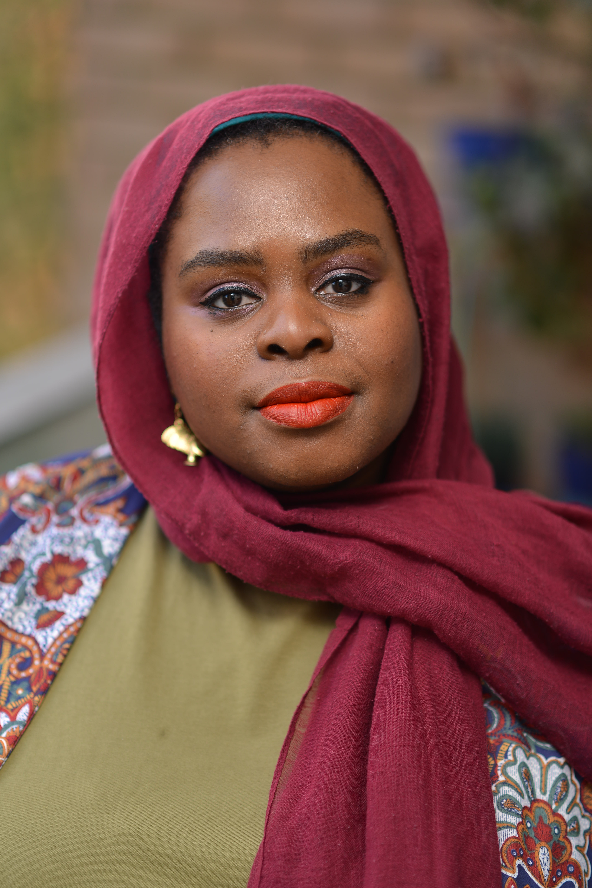

Muneera Pilgrim is a Poet, Cultural Producer, Writer, Community Researcher, Broadcaster, TEDx Speaker, and WOW Festival Speaker with international acclaim. She conducts workshops, shares art, guest lectures, hosts, and finds alternative ways to educate and exchange ideas while focusing on methodologies of empowerment for non-centered people. At heart, Muneera is a storyteller, concerned with telling stories to disrupt mainstream narratives of non-centered people globally and to beautify truths that are rarely told.

Muneera regularly contributes to Pause for Thought on BBC Radio 2, she is an Alumni Associate Artist with The English Touring Theatre where she is writing her first play, and she is an in-house poet and thinker, with In Between Time where she developed The Joy Project.

Muneera has written for The Guardian, Amaliah, Huffington Post, The Independent, Al Jazeera, Black Ballard and various other digital and print platforms. She has been featured across the BBC including BBC News, as well as Sky News, Sky Arts, Al Jazeera, and various other television channels. In 2015 a documentary was commissioned and screened about her former group Poetic Pilgrimage Called Hip Hop Hijabis.

Muneera holds an MA in Islamic studies where she focused on Black British pathways to spirituality, migration, gender, and race. She holds a second MA in Women’s Studies, where she focused on the intersection of faith and spirituality, race, gender, autoethnography and methodologies of empowerment for non-centered people. Her innovation in her work and the use of poetry won her The Ann Kaloski-Naylor Award for Adventurous Academic Writing.

She etches a poetic space of dialogue which is accessible to all regardless of religious and cultural boundaries. Rooted in spirituality she uses communication and art for edification, enrichment and change.

Her Debut Poetry collection 'That Day She’ll Proclaim Her Chronicles’ was released in November 2021 through Burning Eye Books

Parallel Session E, Room G.HO4

Religion, Power, and Public Health

Chair: Mathew Guest

Class and Coloniality in Mission: Stories of Personal Transformation that Overcame Power Imbalances
Victoria Turner (University of Edinburgh)

This paper will draw upon my PhD research that investigates the liberation theology inspired missional paradigms of the Iona Community (1938) designed to overcome the class divide in Scotland, and the Council for World Mission (1795/1977), which aimed to eradicate coloniality still present between Western and Non-Western churches engaged in mission. It focuses on the characters of George MacLeod (1895-1991) and Bernard Thorogood (1927-2020) who pioneered dramatic changes in the thought of, and practice of, mission in and from Britain. Their aims were to overcome power imbalances – between those with economic privilege and those belonging to the working-classes for MacLeod, and to overcome a one-way direction of mission ("from the West to the rest") for Thorogood.

The significant link between both men are their personal stories of transformation that led them towards their theologies of mission. MacLeod became exposed to his own privilege whilst serving with men from disadvantaged backgrounds in World War 1, and Thorogood's previous confidence in foreign missions was shaken after meeting Christian leaders from the Non-Western world.

These encounters led both characters into period of questioning and humility, that formed an 'incarnational' theology in each which emphasised the ability of all to access and hold 'truth' from the Christian faith. These radically inclusive, and popular theologies enabled both to dramatically change the structures for, and reasons for, conducting mission in Britain in the 20th century. At the centre of each's work was the stripping of their own power to elevate the marginalised in each's contexts.

Commemorations and Community Outreach: Shi‘i Muslim Leaders of Metro Detroit Take on the COVID-19 Pandemic
Rose Wellman (University of Michigan - Dearborn)

On March 11, 2020, the World Health Organization declared the coronavirus (COVID-19) outbreak a global pandemic, spurring dramatic changes in public health policies, travel between countries, and (trans)national economies, as well as in religious and political institutions. In the United States, the pandemic revealed a fraught relationship between scientific, religious, and political sources of information and leadership – an American “crisis of authority” (Hamdy 2012) wherein many Americans distrusted scientific and medical establishments. This presentation explores how Shi’i Muslim institutions and leaders of metro Detroit navigated these competing authorities, even as their communities faced entrenched societal inequities, including anti-Muslim racism (Islamophobia). Through digital ethnographic research and in-person research as well as interviews with key religious leaders, I explore how Shi‘i Islamic centres and leaders resiliently educated their publics by aligning religious recommendations with scientific medical advice on the principle of self and community preservation. Their approach compels us to better understand not only the relationship between Islam and science but also how sources of religious authority can tether vulnerable communities to forms of (legitimate) knowledge in times of upheaval, divisive politics, and misinformation.

Promoting ‘Don’t Know Mind’ at financial centre--The Female Zen Master in Korean Tradition in Hong Kong
Ngar-sze Lau (Chinese University of Hong Kong)

This paper examines how the import of transnational meditation has enhanced the social status of Buddhist meditation and Buddhist women in the Hong Kong Chinese context. Although there exist traditional Chan meditation practices in Hong Kong, traditional Chinese customs, local popular religions and Buddhism were devalued as superstitious by intellectuals and social elites over the colonial period. Nevertheless, since the 1990’s various transnational meditation traditions, including Theravāda and Tibetan traditions, have been introduced to Chinese societies. There has been an increasing number of people accepting meditation as a practical way of mind-body healing. Su Bong Zen Monastery, following the teaching of Master Seong Sahn in promoting ‘Don’t Know Mind’, is the first Korean Zen organization established in Hong Kong at a financial centre. The first abbess Zen Master Dae Kwan, who received Dharma transmission in 2001, has successfully attracted lay followers. Dae Kwan and the community have organized the yearly event ‘Zen Meditation with Thousands’ successfully since 2015 aiming at healing anxiety and promoting social harmony for the unrest city. Online meditation activities have been provided to the community for the need over the pandemic. All these socially engaged activities have greatly promoted the positive image of Chinese Buddhism in Hong Kong despite the challenges from some misbehaving monastics. With the case of Dae Kwan and Su Bong Zen Monastery, this paper examines how transnational meditation can fill the gap of the local Chinese Buddhism and enhance the status of Buddhist women.

Parallel Session E, Room G.HO21

Practices of Secularity

Chair: Joanna Malone

Dealing With Death in a Secular Society
Isabella Kasselstrand (University of Aberdeen)

Previous research has argued that as we age and as we face crises that prompt us to consider the mortality of ourselves and our loved ones, we become more religious. Stark and Finke (2000) noted that as people get older, they begin to “invest in the afterlife” by becoming more religiously active and Stark and Bainbridge (1986) argued that religion serves as a compensator in moments of crises, when what we are really after, such as health or longevity, may not be readily attainable. This paper uses survey and interview data from Sweden to explore how people navigate aging, crises, and mortality in a secular society, where religion has lost much of its power. Findings show that older generations of Swedes are highly secular and do not appear to get more religious as they age. They also show that people use various strategies to deal with crises that are entirely secular in substance and that the lack of religious involvement is not associated with lower levels of life satisfaction.

Christmas as Humanist festival and practice: Ritual and rites de passage in new existential movements
Lois Lee, Anna Strhan, Rachael Shillitoe (University of Kent)

Scholars increasingly regard non-traditional and non-religious existential movements and traditions as analogous to religious ones. At the same time, they observe differences, including the dissociation of nonreligious worldviews with centralised institutions, and the distillation of diverse ritual practices seen in religious traditions to just a handful of non-religious alternatives, particularly associated with death and dying and to a lesser extent with romantic partnership and childbirth. This paper presents findings from ‘Becoming Non-believers: Explaining Atheism in Childhood’, a research project examining the formation of non-religious worldviews in childhood based on interviews with children and their parents and teachers in England. Our research identifies Christmas as a festival involving forms of ritual practice through which parents, schools and local and national communities may work together to cultivate one particular non-religious orientation, liberal humanism, in children. We show also that people participate in Christmas rituals differently according to age, and that childhood itself is separated into immature and mature modes of engagement. Contrary to an anxiety expressed by some humanists about permitting or encouraging children’s beliefs in supernatural beings including Father Christmas, we argue that changing orientations towards such beings provides a process through which humanism’s evidentialist episteme is developed and celebrated. In this way, Christmas functions as a significant rite de passage in the formation of humanism. We argue that these findings could sensitise researchers to the existential dimension of diverse cultural practices that have not previously been understood in these terms, to better understand new, often individualised or decentralised existential movements.

Ritual, Royalty, and Religion: Reflections on the mourning of Queen Elizabeth II
Rob Barward-Symmons, Rhiannon McAleer (Bible Society)

The state funeral of Queen Elizabeth II in September 2022 is likely to have been the most viewed religious event in global history. Broadcast on radio and television around the world and simultaneously shared and discussed across every digital platform, billions would have been exposed to a ceremony that was Anglican at its very core, built around the texts of scripture and liturgy of the Book of Common Prayer. The service was preceded by a week of mourning rituals in which, again, religion and specifically Christianity were presented as central to the British state events - events that consumed the airwaves of a now majority non-Christian nation. This paper, based on a commissioned survey of 3000 people across England and Wales undertaken by YouGov, seeks to explore how this was received by the public, what impact it had, and whether there is a desire for change in the religious tone of these events.

The study found a continuing appetite for Christianity and the Bible to remain at the heart of British state events - among non-Christian and even non-religious audiences. However, there simultaneously emerged a clear and growing trend away from people wanting a Christian funeral, with less than half wanting any Christian element in their own rituals. The research therefore opens up wider questions of the role of religious ritual, and religion more generally, in different spheres of contemporary British public life as we look ahead to a new era of royal and state ceremony.

Parallel Session E, Room G.HO29

Power and Religious Outsiders

Chair: Daniel DeHanas

Religion and Power: A Theoretical Perspective on the Micro and Macro Levels of the Social and Power Dynamics of Religious Shunning
Windy Grendele, Savin Bapir-Tardy (Regent College London; University of Roehampton)

Religion is one of the most powerful forces in society, providing millions of people with a sense of meaning, purpose, and unity and shaping their beliefs and behaviours (Weber, 1920). However, religion has also served as a means of social control and coercion, with those in positions of power using religious beliefs and punishments to justify and maintain their dominance. Religious shunning is a practice adopted across religious organisations that are described as being authoritarian (Oblak, 2019). In these organisations, shunning is used as an effective tool to coerce and manipulate their affiliates (Oblak, 2019).

To appreciate the effectiveness of this disciplinary measure, it is necessary to adopt a theoretical perspective that integrates the micro and macro levels of the social and power dynamics which develop within the religious community. Based on the findings of a study conducted to explore the lived experiences of being shunned from the Jehovah’s Witness community, the Integrated Model of Social Dynamics and Coercive Power Construct exemplifies the way social dynamics (Breakwell, 1986; Tajfel and Turner, 1979) and the constructs of power (French and Raven, 1959; Pratto et al., 1994) combine in justifying the dominance of one group over another. The model demonstrates how this dominance is justified as being the will of a divine entity and in turn validates the use of coercive tactics to sustain and maintain the status quo.

Conspirituality: The Dark Arts of Manipulation
Martin Rooke (Harvard Kennedy School, Shorenstein Centre)

The growing phenomenon of "Conspirituality," the convergence of conspiracy thinking and ‘New-Age’ belief systems (Ward and Voas, 2011; Jennings, 2021), has been overlooked in recent scholarship on the risks posed by conspiracy thinking within the Christian Nationalist movement (see Gorski et al, 2022). This presents a concern as both conspiracy and spiritualist content have become increasingly popular online, particularly on social media. Through a research project into cultural collapse conspiracies, it was observed that Conspiritualist frameworks amplify the conspiracist view of elite/institutional agency, drawing from the apocalyptic emblems and naturalistic sense-making of spiritualism.

Vulnerable internet users may be at risk of social harm and radicalisation, internalising narratives resistance against a perceived spiritual war against a ‘demonic elite agenda’ (Green et al, 2022). Online Conspiritualist movements may attract vulnerable internet users by providing an alternative sense-making tool. Central to these movements is the belief that powerful institutions keep metaphysical truths and knowledge hidden from the public (Greenwood, 2000).

This paper explores how Conspiritual discourses aid self-radicalisation by developing a consumptive framework of spiritual sense-making. This paper uses the Cultural Theory of Risk (see Douglas 1966, Douglas and Wildavsky, 1983) to detail the metamorphosis of radicalising discourses in the context of deconstructed religion and individualised spiritual wellness. The popularity of Conspirituality represents a continuing shift towards individualised sense-making systems based on folk logic, as opposed to relying on the social convergence of religion, science and political definitions of danger and safety (see Douglas 1966, Douglas and Wildavsky, 1983).

Politics, Protestantism, and “Pseudoreligion”: The Shincheonji Church of Jesus and Mainstream Protestantism in South Korea
Mary Briggs (The University of Edinburgh)

In February of 2020 international news outlets reported on the connections between a new millenarian Christian church known as the Shincheonji Church of Jesus (hereon Shincheonji) and a COVID-19 cluster infection in the South Korean city of Daegu. Although these alleged connections to South Korea’s COVID-19 epidemic catapulted this minority religious community into the global spotlight, Shincheonji has long faced scrutiny from the mass media and Protestant churches who often referred to the church as a heretical cult (idan) or pseudo-religion (saibi chonggyo). In this paper, I first discuss a prominent popular narrative about Shincheonji that I identified while researching the relationship between Shincheonji and the South Korean state. This narrative states that Shincheonji works to destroy Protestantism by stealing members of other churches through trickery and deception. Since this narrative features in media programmes such as news broadcasts and documentaries, which claim to inform the public, it profoundly influences how many South Koreans perceive the church and treat its members. I then present accounts of current and ex-Shincheonji members that I collected during my research to paint a more complex picture of the diverse ways people have come to join the church. I argue that this discontinuity between the aforementioned popular narrative and the accounts of members illuminates anxiety surrounding the declining popularity of Protestantism in South Korea. I then explain how this decline, when paired with the simultaneous growth of Shincheonji in the past two decades, unsettles the state due to Protestantism’s historic political and economic power in South Korea.

Parallel Session F – Friday 7 July 14:00 – 16:00

Author Meets Critic Session, Room G.H01

Neoliberal Religion: Faith and in the 21st Century

Chair: Rob Barward-Symmons

Session organisers: Mathew Guest, Abby Day, Daniel DeHanas

Neoliberalism is a perspective grounded in free market economics and distinguished by a celebration of competition and consumer choice. It has had a profound influence in societies across the world, and has extended its reach into all areas of human experience. And yet neoliberalism is not just about enterprise and opportunity. It also comes with authoritarian leadership, gross inequality and the manipulation of information. How should we make sense of these changes, and what do they mean for the status of religion in the 21st century? Has religion been transformed into a market commodity or consumer product? Does the embrace of business methods make religious movements more culturally relevant, or can they be used to reinforce inequalities of gender or ethnicity? How might neoliberal contexts demand we think differently about matters of religious identity and power?

In this new book, Mathew Guest asks what distinguishes neoliberal religion and explores the sociological and ethical questions that arise from considering its wider significance. He will present the book in broad outline, before responding to critical responses from Professor Abby Day (Goldsmiths) and Dr Daniel DeHanas (King’s College London).

Parallel Session F, Room G.H03

Power in Academia

Chair: Peter Hemming
Co-creating Dilemmas: Reflections on power in research collaborations between academics and church/charity practitioners
Kirsi Cobb, Holly Morse (Cliff College)

In 2021 we launched an AHRC research network, Abusing God: Reading the Bible in the #MeToo Age. It aims to connect academics, church, and charity practitioners as co-producers of collaborative research into the intersection between Scripture and the lived experience of Christian survivors. At the project’s core is a methodological concern to explore and challenge perceived/experienced power dynamics that exist between the Academy, churches, and charities, and between academics and practitioners. In the context of our field of biblical studies, which is often distanced from potential contemporary social impacts of the research it produces, we argue scholars must address the implicit hierarchies this approach engenders in knowledge production on religion and power. Our response seeks to create opportunities to break down potential disciplinary and specialist boundaries via academic and practitioner led co-creation. Our project has explored different ways of facilitating these research relationships, and methods for authentic collaboration which is not solely output led but instead is led by informal conversation and reflective research and writing. We argue that it is through attending to these issues of methodology and research practice that we can create space for the emergence of effective resources that support culture change in churches around gender-based violence, and innovative academic research on the Bible that addresses these same issues. The aim of our paper is to describe and evaluate some of the findings of the project to date, in particular regarding methods for de-centring power in the production of academic research into religion and abuse.

Prison chaplaincy and the marginalisation of non-religious offenders
Katie Hunt (University of Lincoln)

This paper reveals the ways in which prison chaplaincy marginalises and - I argue - discriminates against the non-religious, both as service users and pastoral care providers. The first half explores non-religious prisoners’ unequal treatment and unequal opportunity in accessing belief-appropriate support, critiqued through the lens of the Equality Act 2010. Informed by interviews with Non-Religious Pastoral Support Network members, the second half of the paper outlines the challenges that volunteers face when trying to support people with non-religious beliefs behind bars. Here especially we see power dynamics of inclusion and exclusion at work, stemming from the established church and Anglican monopoly of prison chaplaincy. The paper concludes with recommendations for reform, to reduce discrimination on both sides of the pastoral care relationship. The full paper can be accessed for free at: doi.org/10.1017/S1744552322000039.

How can the Poetics of Goddess Spirituality inform Interior Design? (PhD Student 2nd Year)
Emilia Welton (University of Kent)

This paper will examine the relationship between power, gender, religion and interior design.

A person-made space holds narratives, beliefs and memories; essentially mirroring human consciousness. Space can impact human beings’ understanding of themselves and others by collecting and reflecting societal attitudes, and ultimately, bringing about changes in behaviour and worldview. Gender politics are very much ingrained into the foundations of our everyday environment and many researchers have begun to identify how the material world still upholds patriarchal values. Now researchers in interior design have begun to explore what effects feminism may have in counteracting materialised manifestations of patriarchy.

I propose to look at this through a spiritual feminist lens. Carol Christ and other core spiritual feminists emphasise the concept of immanence; that the spiritual is not separate to but within the physical world, part of us and of nature, and instilled within what we create. Theological literature is full of metaphysical and mythical symbols of internal sacred space that have strong relationships with transformation.

I will argue in this paper that the poetic representation of the goddess can be found inside features of designed interior spaces / interior artefacts. I will also argue that these representations could form a pathway for reconnecting to a balanced state of humanity. The improvement of the environment, gender equality, stronger community, and other issues undermined by patriarchal oppression could be greatly enhanced by utilising the interactive relationship between space-making and culture and embedding affective spaces with the philosophies of Goddess spirituality.

Parallel Session E, Room G.HO4
Religion and Education

Chair: Sarah-Jane Page

Selection and Space: Exploring how power dynamics influence equal status among school students taking part in interfaith contact
Lucy Peacock (Centre for Trust, Peace and Social Relations, Coventry University)

This paper is based upon research which examined the relationship between ‘interfaith contact’ and ‘peaceful relations’ among young people in London’s schools. The mixed methods research explored the effectiveness of The Faith and Belief Forum’s ‘School Linking’ programme, which trains teachers in interfaith dialogue facilitation skills and brings students together to creatively engage with questions of identity and belief.
The paper explores fundamental questions related to School Linking. Who is in the room? Through what methods are students selected to take part? How do students perceive and experience the spaces in which School Linking operates? Drawing upon teacher focus groups and participant observation in four secondary schools, the paper argues that methods of selecting students for interfaith contact channel different ‘dimensions’ of power (Haugaard 2012). The resulting power dynamics have implications at a) interpersonal levels, where selection methods risk generating tension between parental consent and student agency, and b) institutional levels, where selecting ‘gifted’ students for interfaith contact align with neoliberal educational agendas. Furthermore, the spaces in which students interact become relational; students must navigate power imbalances when adopting hosting-visiting roles during school visits.

These findings will be discussed in relation to the theoretical underpinnings of School Linking: intergroup contact theory (Allport 1954). The findings provide first of its kind contextualised evidence for the ways in which equal status, a key condition for ‘successful’ contact, is established and negotiated during interfaith encounters in schools, identifying ways in which future contact might be effectively managed.

Power in the Classroom: Making Sense of RE
Tim Hutchings, Celine Benoit (University of Nottingham)

The 2021 census showed rapid decline in Christian identification in England and Wales and a swift increase in nonreligious identification. In schools, however, this process of change meets entrenched foundations of historic religious (and specifically Christian) power, including the vast network of state-funded faith schools, the legal obligation of daily collective worship and the compulsory status of RE. In community schools, RE is taught according to a curriculum developed by local committees (SACREs) on which professional teachers represent only one of four voices, outnumbered by groups representing the Church of England, other religious groups, and local authority advisors.

This presentation focuses on recent attempts to change the educational paradigm of RE to promote a new approach based on the study of religious and nonreligious worldviews. According to reformers, this new approach will be academically rigorous, decolonized, sensitive to diversity and personally meaningful to pupils. According to critics, the study of worldviews is anti-intellectual, motivated not by genuine educational aims but by a desire to dismantle the privileged place of Christian theology in British schools.

To make sense of the vehemence of this debate, we must study how power operates in RE: who wields it, how they maintain it, and what goals they hope to accomplish. We have surveyed and interviewed a national sample of primary and secondary RE teachers, supported by additional interviews with RE advisors. Our analysis presents RE as a space in which factions collude and compete to gain power over the classroom, presenting immense challenges to reform. For stakeholders, RE is not just a school subject but a unique space in which to challenge or to reinforce the place and power of religions in society.

Religious Citizenship and Agonism: Conflict, Consensus and the Endeavour to Include
Jeremiah Adebolajo (University of Worcester)

As the discourse surrounding deliberative educational practices enters the social imaginary in new ways and emerges as a subject of sociological inquiry (Backer, 2017; Lo, 2017; Longo, 2013), the early findings from my doctoral research raise important questions about the limitations of conflict-averse educational paradigms, particularly as they relate to religious pluralism in contemporary Britain.

Through an ethnographically oriented investigation into the identity configurations and educational experiences of fifteen millennial-born Muslim converts, my study indicates that converts tend to construct deeply religious identities, characterised by religious literalism. Therefore, set within the backdrop of an educational context that some have argued is becoming increasingly censorious (Stock, 2021), convert Muslims provide an interesting lens through which to examine the contested spaces within which religious subjecthood and political emotion can be expressed.

Bringing the literature challenging the securitisation agenda in education (Durodie, 2016) into conversation with a body of literature resistant to the impulse to seek consensus in social and educational debate (Mouffe, 1999; 2013), this paper will argue the case for more agonistic approaches to education. My early research findings will offer examples that warn of the ways in which a hardened secular deliberative approach may contribute towards an unmooring of the pluralistic endeavour of multiculturalism.

Located within much broader contemporary debates about the limits of free speech, the rise of transgressive thought and the place of radical democratic theory, the paper advocates for the expansion of opportunities to disagree.

Parallel Session E, Room G.HO21

Short Presentations Slot 3

Chair: Isabella Kasselstrand

Harmony and conflict: the individual and religious views of autism
Eli Gemegah (University of Birmingham)

The complex and intricate role of religion on people’s lived experiences is usually silenced in an ever-growing secular society. This paper considers and outlines religion’s influence on parents’ experiences of their child’s autism, to convey nuanced areas that are underrepresented in existing literature. Negative cultural beliefs of disability are prevalent in the Black community in the UK. Particularly within the African community, disability is attributed to supernatural forces, a curse, punishment from gods or ancestors. Black parents (N=15) of children with autism were interviewed to examine the role of religion in their lived experiences. The findings showed that religious beliefs of disability influence the community’s perceptions, attitudes and awareness of autism. As such, parents experience stigma and marginalisation in their community and within religious organisations. Parents’ experiences of stigma can influence and paralyse their willingness to seek for help in the form of early diagnosis, intervention and parent support groups. Mothers expressed strong religious identities and depended on their religious faith as a framework to make sense of their life experiences, in general and of autism. In this study, parents adopted a religious lens to understand and cope with their child’s diagnosis and sought support from their religious practices, which entailed prayer, faith and belief in a higher power and Bible/ Quran readings. The findings from this study have implications for Black parents’ mental health and wellbeing, especially as seen through the lens of religious factors and contributes to debates about individual wellbeing within a broader social milieu.

Experiencing hope in the ‘immanent frame’: the legacy of transcendence and eternity
Sarah McKean (University of the West of Scotland)

Hope is a complex, yet familiar, concept. The source, experience, and product of hope can be powerful. Desistance literature talks of the power of hope to invigorate and support a life free from crime (Weaver, 2016). Conversely, hopelessness is also identified as a catalyst for re-offending (Schinkel and Nugent, 2016; Halsey et al.,2017).

Taylor’s immanent frame, (2007), suggests that the contestability of faith is only possible due to a pre-modernity axiom of religiosity. This religious legacy also speaks to the human capacity to imagine, or engage with, transcendence and eternity. Hope, due to its elusive nature sits comfortably in the space of both imagining and other worldliness.

This paper will draw upon research gathered from 3 groups of men at differing, significant, stages of the desistance process: 1) those 6 weeks prior to release from prison; 2) those who have been released between three to six months; and 3) those who have been released from prison two years or more. Through participant photography, collage creation and two interviews 6 months apart, the nature of hope, how it is experienced and understood, hope catalysts and hope sustainers were uncovered. The majority of participants stated that they had no religious affiliations.

The paper speaks to the ability of theological and sociological, in this case, criminological, conversations to widen pluralistic understandings of social phenomena such as ‘hope’. It also suggests that despite existing in this ‘secular age’, beliefs once founded in religion can act as a mechanism for individual and social change.

Godlessness in Alcoholics Anonymous
Lucy Clarke (University of Kent)

This talk will explore how narratives around agency, power, and selfhood, imbue the spiritual approach of godless members of Alcoholics Anonymous (AA). AA is an international mutual help fellowship which is described as ‘spiritual but not religious’ in its literature and by its members. This spirituality is structured around a 12-step programme, which encourages members to develop a relationship with a Higher Power. Members choose their own Higher Power – some choose an Abrahamic God, others choose nature, or other people, or even AA itself. Members variously pray, surrender, and ‘admit wrongs’ to their Higher Power. This project explores how this works for members who are atheist, agnostic, or otherwise non-theistic, or godless.
I am interested in how people integrate the programme into their everyday lives and the ways that they engage with AA practices through recovery. Established members of AA express that these spiritual practices have facilitated a necessary, radical change in their lives. Many describe feeling more at peace with the world, having experienced extreme hopelessness prior to AA involvement. Narratives of radical change through spiritual practice are rare in studies involving nonbelieving people, which has largely characterised nonbelievers as rationalist and materialist, with individualised conceptions of agency. This work explores the flexibility of secular discourse and how it can manifest in such a setting. It speaks to the complex ways that people embody and enact nonbelieving identities.

Parallel Session E, Room G.HO29

Salafism and Politics

Chair: Michael Munnik

Of Friends and Foes: Paths to Salafi Politics
Guy Eyre (ESRC Post-Doctoral Fellow at SEPAD Lancaster University; Post-Doctoral Fellow at the Alwaleed Centre in Edinburgh University)

Salafism is one of the most important Islamic ideologies of the past 70 years (Bano 2022). In many ways the ideological core and 'ideal-type' of Salafism worldwide, this paper looks at how so-called ‘quietist’ Salafism specifically - who claim they ‘don’t do politics’ - actually do do politics. Scholarship on Salafism, and Islamic politics more generally, typically dismisses these 'quietist' Salafi actors – who continue to reject involvement in formal politics as 'corrupt' and 'corrupting' and who focus instead on religious education and da'wah (proselytisation) – as ‘pre-' or 'non-political’. This paper, however, argues that, by failing to engage with political and social theory on the nature of power and (identity) politics (Bourdieu 1984; Schmitt 1999; Mouffe 2000), scholars miss the shifting nature of Salafism as a religious-cum-political project involving a power-laden politics of (i) intra-Salafi friendship and (ii) boundary-drawing vis-a-vis 'deviant' of competing Islamic groups, state institutions, and the Muslim mainstream; a project animated not only by elite scholars but increasingly by non-elite, rank-and-file activists in interpreting and circulating ideas of not only doctrinal and ritual orthodoxy, but also politics, democracy, and societal transformation. This paper thus asks: how do politics and political power unfold at this popular Salafi level? Via textual analysis, and ethnographic data and interviews with Salafis in North Africa specifically, this paper therefore contends that these 'quietist' Salafis’ power-laden political practices shape the conceptual subjectivities and attitudes of Salafis and community members concerning who they (don’t) associate with and what practices are (il)legitimate and (un)desirable.

Conceptions of (in)equality in minority religious organisations’ political claims
Pier-Luc Dupont, Thomas Sealy, Tariq Modood (University of Bristol)

The forms and causes of discrimination against religious minorities, as well as the appropriate legal and political responses to it, are highly politicised issues which can be approached from different conceptual premises. Drawing on semi-structured interviews with the leaders of UK-based religious organisations, this paper will delineate three normative perspectives on the problem and its potential solutions. The first perspective, labelled ‘multiculturalist’, understands discrimination as a consequence of racial, ethnic and religious biases ingrained in public institutions, the economy and the dominant media. To overcome this, it advocates a remaking of national citizenship so that minorities are regarded as fully British, with an inclusive national imaginary, laws and greater minority representation in positions of power and influence. The second perspective, characterised as ‘interculturalist’, foregrounds more horizontal, everyday forms of discrimination, driven by widespread prejudices among the population. Viewed as a cause and consequence of residential, educational and employment segregation, these prejudices should be combatted by creating opportunities for people from different backgrounds to mix and mingle, with local policies and solidarities valorised over the national. The third perspective, which could be described as ‘cosmopolitan’, zooms in on the inferior legal treatment offered to migrants compared with citizens. In this light, strengthening the social rights and residential security of migrants and asylum seekers on the basis of human rights rather than equal citizenship appears as a priority. Importantly, these perspectives are not mutually exclusive but often find themselves simultaneously reflected in the discourse of a given organisation.

Post-Salafism: Contradictions & Everyday Lived Realities in London’s Salafi Community
Iman Dawood (University of Cambridge)

Salafi approaches to Islam have exerted much power and influence within the religious sphere of Muslim-majority and Muslim-minority countries around the world. Within the UK, Salafi groups have, over the last four decades, worked to reshape the way Islam is understood and practiced not only by self-identifying Salafis, but by many within the larger Muslim community. In the last decade, however, Salafism has begun to undergo several challenges leading a few scholars to speak of the advent of “Post-Salafism” (Blanc and Roy, 2021; Razavian, 2018; Sinani, 2022; Thurston, 2019). Nonetheless, our understanding of what exactly Post-Salafism is, and what has led to its emergence, is still lacking.

This paper contributes to our understanding of this phenomenon by shedding light on the challenges that Salafism has recently experienced within the UK context. It is based on more than 150 in-depth semistructured interviews, and participant observation in multiple Salafi and non-Salafi mosques and events in London between 2017- 2019. It argues that scholars’ current focus on Salafi scholars and leaders only goes so far in explaining Post-Salafism. Instead, it stresses that it is necessary to pay attention to the everyday lived experiences of those in Salafi communities in order to capture the subtle forces at work in Post-Salafism. By drawing on Gramscian theory, this paper contributes to our understanding of the relationship between religion, power, and everyday experiences.

