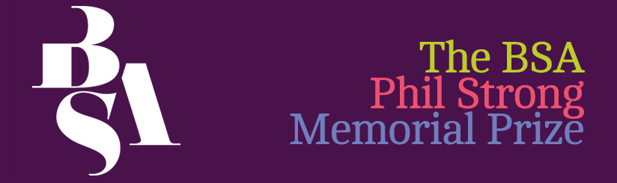

Application for the Phil Strong Memorial Prize

This form should be completed and returned to the BSA office by no later than 5pm on Friday, 9th August 2024 to: enquiries@britsoc.org.uk or post to: Phil Strong Memorial Prize, The British Sociological Association, Chancery Court, Belmont Business Park, Belmont, DURHAM, DH1 1TW
For more details please go to: http://www.britsoc.co.uk/medsoc/PhilStrong.htm

Applications will be judged against the following criteria:
- Clarity: Is there a clear description of how the prize will be used?
- Relevance to Medical Sociology: How closely does the research align with the core concerns and themes of medical sociology as a field of study?
- Impact: is the impact of the research outlined? This could relate to impact on the applicant, on their study, on the field of study, on key communities etc.
Applicant details
Name:
Institution:
Address:
E-mail: Contact number:
BSA membership number:
Degree registered for:
Date registered:
Expected date of completion:
Supervisor details
Name:
E-mail:
Institution and institutional account through which the prize would be administered:
Signatures
Applicant signature:
Date:
I confirm that the details in this application are correct
Supervisor’s signature:
Date:

Study details
Study title:

Summary of research, please provide an outline of your study, including background, aims and objectives, methods and any finding to date, max 400 words:
Summary of research:

Prize Details
Proposed use of prize, please provide details of the activities to be supported and timetable, see note below, max 300 words:

Costs, please provide an itemised breakdown of the likely costs and total costs:

.
Outcomes of prize, please provide a statement of how:
- the prize would contribute to the field of medical sociology;
- the impact of the prize (this can be on yourself as a researcher, on your project, on key communities, on the discipline etc.), max 500 words:

NOTE

The Phil Strong Prize Money may not be used for:
- Funding living expenses (e.g. rent);
- The material production of a thesis (e.g. photocopying and binding) (the BSA has a fund to which students can apply for this –http://www.britsoc.co.uk/students/SupportFund.htm);
- Courses which should be offered by the Department/Unit as part of normal provision for postgraduate or undergraduate students (e.g. standard courses in research methods);
- Return fares for an overseas student, registered in Britain, to return home. Exceptions may be made if there is strong evidence of how this would advance the study;
- Materials and equipment such as books, computers (including access to the internet) and tape-recorders which should properly be supplied by the sponsoring institution; and
- Any purpose which is unlawful.

