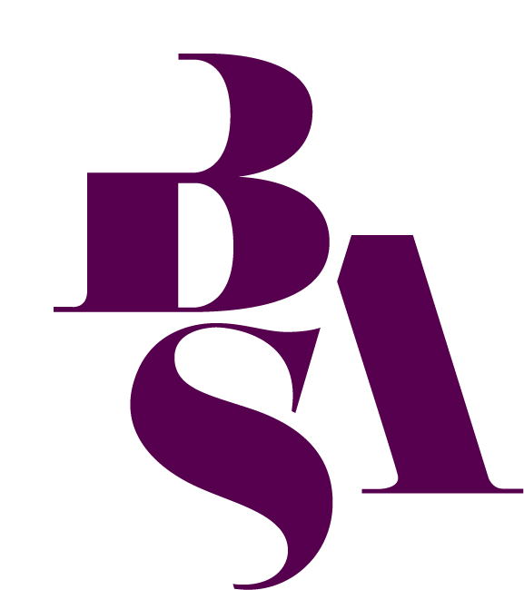**BSA Young Sociologist of the Year Competition 2025**

**Win an iPad for you and recognition for your school or college!**

Are you aged 16-19 and studying Sociology at A-level, AS-level, Scottish Higher or equivalent post-16 qualification? If so, this is your chance to enter a national competition exploring a key sociological theme, and showcase your creativity and insight. Winners in both the written and audio-visual categories will each receive a brand-new Apple iPad!

We encourage you to be as creative and original as possible in your approach – whether you choose to write an essay, record a podcast or produce a short video. Use your sociological imagination to engage with the topic in a way that feels meaningful and insightful to you.

If you have any questions about the competition criteria, please contact the BSA Membership Team at [enquiries@britsoc.org.uk](mailto:enquiries@britsoc.org.uk).

**2025 Theme:**

***‘What are the most significant social challenges facing your generation?’***

What are you interested in? How does your interest relate to this question? Use sociological theory, concepts and examples to craft your entry.

You can submit your work in one of two formats:

* **Written Essay** (approx. 2,000 words)
* **Audio-Visual Submission** (e.g. podcast or video, max 10 minutes)

**Key Criteria and Updates for 2025**

* A **maximum of 5 entries per school or college** will be accepted across both formats. If more than five entries are submitted, we will contact the teacher listed on the form to select five for consideration. If we do not receive a timely response, only the first five entries submitted will be judged.
* **Primary research is optional** – You may include your own empirical research (e.g. surveys or interviews), but it is **not required**. Where research is carried out, this must abide by the BSA’s [Statement of Ethical Practice](https://www.britsoc.co.uk/media/24310/bsa_statement_of_ethical_practice.pdf).
* Both the **written and audio-visual category winners** will receive **an iPad**.

**Audio-Visual Submission Guidance**

* Submissions must be no longer than 10 minutes.
* Accepted formats: MP4, AVI, or WMV (must be playable on standard Windows PCs).
* Do not submit Apple-only formats such as .mov or. keynote.
* Please **ensure your video or podcast submission does** not **include your full name or school within the file (e.g. in the title, spoken content or visuals), as entries are judged anonymously.**
* We recommend sending your audio-visual entry from the same email address used on your application form or attaching it alongside your completed entry form.
* If your entry is selected as the winner, we will contact you to request a version that includes your name and school for promotional purposes (e.g. on our website or Discover Sociology).

**Deadline:** **Monday 3rd November 2025, 4pm  
  
How to enter:** Please email your entry and this completed form to [enquiries@britsoc.org.uk](mailto:enquiries@britsoc.org.uk) or post it to: BSA Membership Team, British Sociological Association, Chancery Court, Belmont Business Park, Belmont, Durham DH1 1TW.

**Terms and conditions:**

* Entries must be accompanied by confirmation from a Sociology teacher that it is the work of the pupil.
* All work must be your own and submitted individually (no joint entries).
* Essays must be around 2,000 words (excluding bibliography, figures, tables etc*.*)
* Entries submitted in the form of a video or podcast must not exceed 10 minutes.
* We reserve the right to check submitted works for plagiarism using online tools.
* Reference to other scholars (including teachers, books, articles and websites) should be acknowledged.
* All work must be written or presented in the English language.
* The judges’ decision is final and we reserve the right to publish your entry with your permission.

**Entry details**

Title ________ Surname ___________________________ First name(s) ______________________

School / College name ______________________________________________________________

School / College address ____________________________________________________________

_________________________________________________________________________________

Post code ______________

School / College Year _____________ Email address ____________________________________

Tel. no. (Day)___________________________ Mobile No. _________________________________

Date of birth _______________________

Entry format: Essay ( ) Podcast ( ) Video ( ) Date__________________

**Teacher Declaration (required for all entries)**

*Please ask your Sociology teacher to complete this section.*

Teacher’s name: _______________________________________

Teacher’s email address: _________________________________

I, ____________________________________________, confirm that the entry submitted by the student named on this form is their own work.

Signature: ______________________ Date: ________________