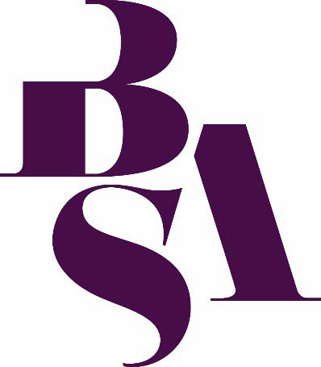
Are you interested in being a BSA Sociology of Education convenor?
The BSA Sociology of Education Study Group is looking for two new convenors to join Dr Achala Gupta and Dr Jon Rainford

The Study Group aims to bring together those interested in the sociology of education in order to:

exchange and develop ideas
encourage collaboration
lend support (particularly to research students)

We are interested in all aspects and levels of education and training including compulsory education, pre and post compulsory education, full-time and part-time, and formal and informal.
Other aspects of the role entails:
- Sharing relevant information and events with members using the jiscmail list
- Organising occasional events/workshops
- Managing the group’s budget
- Liaising with the BSA
- Representing the study group at BSA Study Group meetings
- Organising streams and plenaries for the BSA annual conference, as well as conference chairing

We would be particularly keen to hear from postgraduate and early career researchers who might be keen in developing the events and social media presence of the group.

Convenors must be a paid-up member of the BSA.

If you are interested in becoming a convenor we ask that you write a brief summary of your academic position and experience and outline your interests in Sociology of Education alongside a brief outline of how you think you will be able to contribute to the group’s development.

If you are interested in volunteering for this position, please register your interest with Jackie Murphy Jackie.murphy@britsoc.org.uk or Jon Rainford jon.rainford@open.ac.uk by
Friday 6th March 2026.
Please note: The call may close early if all positions are filled before the deadline.



