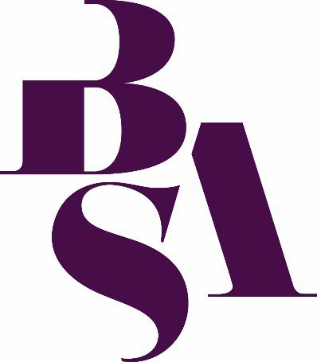

The BSA North West Medical Sociology Regional Study Group is seeking new convenors to take over the group.

Would you like to become more involved in the Study Group? We are looking for individuals who are passionate about continuing and developing the Study Group over the coming years.

This is a valuable opportunity to help shape the direction of the Study Group, support its members, and contribute to building an active and inclusive space for sociological research, dialogue, and collaboration in the field.

The Convenor plays a key role in leading the Study Group, which includes:

- Coordinating group activities and events (such as seminars, workshops, or conference panels)
- Engaging with Study Group members and facilitating communication
- Supporting the promotion and visibility of the group within and beyond the BSA
- Liaising with the BSA, including writing a short annual report outlining Study Group activities
- Representing the study group at BSA Study Group meetings

Convenors must be BSA members and maintain their membership for the duration of their tenure in the role and must sign the BSA Study Group Terms of Reference.

Further information on the group is available at: https://www.britsoc.co.uk/groups/medical-sociology-groups/north-west-medical-sociology-regional-group/

Please email donna.bramwell@manchester.ac.uk or enquiries@britsoc.org.uk with expressions of interest, including what you could bring to, and how you might benefit from, the role by Monday 12 October 2026.

Please note that if no convenor is found before this date the BSA Food study group will become inactive and cease to exist.

Looking forward to hearing from you!

